SYLLABUS
- Origin and Nature of pharmaceutical legislation in India
2. Code of Pharmaceutical Ethics
3. The Pharmacy Act 1948
4. The Drug & Cosmetics Act 1940
5. The Drug and Magic Remedies Act 1954
6. Narcotic Drugs & Psychotropic Substances Act 1985
7. Drug Price Control Order
8. Medical Termination Of Pregnancy Act 1971
9. Medicinal & Toilet Preparation Act 1956

Origin and Nature of pharmaceutical legislation in India
Q. 1. Write an essay on the historical development of pharmacy as a profession in India.
Ans: The history of Indian medicine can be traced back to 800 B.C. when Ayurveda, the Hindu system of medicine was part of the ‘Atharvaveda’. The classics of Indian medicine are treatises by chakra and sushruta (500 to 600 A.D.) which are primarily based on contents derived from the Vedic period.
Ayurvedic therapies use medicines of plant and animal origin as well as those derived from metals, minerals, gems, jewels, etc. the ayurvedic system dealt elaborately with the methods of preparation of drugs and flourished well till the coming the unani system. TheUnanitibb system of medicine is based on the teachings of Hippocrates and Galen and owes its origin to Greece although Arabs gave it the scientific base. Another ancient Hindu system of traditional medicine practiced primarily in Tamil Nadu, Sri Lanka and adjoining areas is the siddha system. This traditional system of medicine is based on “three dosha” theory and mainly uses minerals andmetals though some products of vegetable and animal origin are also employed.
Homeopathic system of medicine even through not very old from the pioneering work of Dr. Hahnemann is based on the principle “similasimli buscuranter” (Like cures like). This system is widely practiced in India as well as in Europe, U.S.A. etc.
The traditional systems of medicine suffered a setback with the advent of the modern or the allopathic system of medicine which came along with the Britishers. This is a scientific system of medicine where a drug has to be proved safe and effective in the treatment of particular disease before it can be legally put into market. However, the fact that despite the widespread use of Allopathy, the traditional medical practice is still found to be use in India only confirms the deep roots it has in the country even today.
The early pioneers of the Indian Pharmaceutical Industry were prof. P.C. Ray of Calcutta and Rajmitra B.D. Amin of Baroda. It was prof. ray who started the first Indian owned drug Firm, ‘The Bengal Chemicals and Pharmaceutical Work’s in Calcutta in 1901. Prof. T.K. Gajjar started a small factory at parel, Bombay in 1903 and Alembric Chemical works was started at Baroda in 1907. The Beginning of modern drug research in India can be traced to early part of the twentieth century. In 1920, Sir Sam Nath Chopra organized an active center of research on Indian Medical plants at the school of tropical medicine, Calcutta. This was the first coordinated effort to bring the vast knowledge of the traditional systems of medicine into the mainstream of modern medicine.
Until the early part of 20th century, the number of drugs was limited and drugs were mostly of vegetable, animal or mineral origin. Drugs were mostly exported in crude from and imported in finished from. The situation, however, deteriorated due to World War I when markets were flooded with indigenous and imported, adulterated, spurious and substandard drugs. The drugs enquiry committee was set up by the government of India in 1928 which ultimately led to the passage of the drugs and cosmetics act in 1940 and the development of pharmacy as a profession in India.
The Drugs and magic remedies (Objectionable Advertisements) Act was passed in 1954 to control the increase in objectionable advertisements relating to drug as alleged cures for venereal diseases, sexual stimulant and female diseases being published in newspapers and magazines or otherwise. These advertisements tend to cause the ignorant and the unwary to restart to self-medication with potential for considerable harm to the individual. The bill, in public interest put a stop to such undesirable advertisements.
The Medicinal and toilet preparations (Excise duties) Act was origin and nature of pharmaceutical legislation in India.

Introduced in 1955 and contained detailed provisions for medicinal and toilet preparations containing alcohol.
The narcotic drugs and psychotropic substances act, 1985 is a timely legislation which provides for exemplary punishment for trafficking such substances.

Q. 2. Briefly discuss the reasons for setting up of the Chopra committee, its recommendations and actions taken by the government upon its recommendations.

Ans: In the early part of the 20th century, there was practically no legislative control on drugs as well as on the profession of pharmacy. Although the Opium Act. 1878, the Poisons Act.1919 and the Dangerous Drugs Act.1930 were in force, these were specific in nature and grossly inadequate in controlling the chaotic conditions prevailing at that time. There were wide spread cases of adulterated, spurious and substandard drugs being manufactured and imported into the country. In 1927, a resolution was passed by the council of states to recommend to the Governor-General in council to urge all provisional governments to take immediate steps to control indiscriminate use of drugs and to legislate for the standardization of the preparation and sale of drugs. The government of India in pursuance to the resolution appointed a committee with Col. R. N. Chopra as its Chairman in 1928 to:
- Enquire the extent to which drugs of impure quality or defective strength were being imported, manufactured or sold in India, and
- Recommend steps for controlling such import, manufacture and sale in public interest.
- Enquire into the necessity of legislation to restrict the profession of pharmacy to qualified persons and to make recommendations.

Recommendations of the Chopra Committee:
The drugs enquiry committee also known as the Chopra committee recommended the following.
- A central enquiry committee also known as the Chopra committee recommended the following:
- Setting up of testing laboratories in all states to control laboratory to control the quality of imported drugs and also to Act as expert referee in case of sample sent by local/state Government.
- Appointment of an advisory board to advise the government in making rules to carry out the objectives of the Act.
- Setting up the courses for training of pharmacists and prescribing minimum qualifications for registration as pharmacist.
- Registration of every patent and proprietary medicine manufactured in India or imported from outside the country.
- Bringing of crude single drugs as well as compounded medicines used in the indigenous systems of treatment under control.
- Development of the drug industry in India.
- Gradual reduction of manufacturing in medical stories/depots.
- Compilation of an India pharmacopoeia.

Actions taken by the government on the recommendations of the Chopra Committee.
Even though it has taken many years before the above recommendations could be enacted into low or otherwise implemented, it is a matter of great satisfaction that the valuable recommendations of Chopra Committee shaped the Future of the profession of pharmacy and pharmaceutical industry in India. The following pharmaceutical legislation and actions of the central government can be traced to the above recommendations:
- The pharmacy Act. 1948 provided the regulations for the profession and practice of pharmacy. The education regulations prescribed the minimum qualifications for registration pharmacist.
- Drug testing laboratories have been set up at state and central government level.
- Suitable advisory boards such as drugs technical advisory board (DTAB) and drugs consultative committee (DCC) have been set up.
- Registration of all drugs and formulations sold in India.
- Pharmacopoeias for drugs used in indigenous system of medicine are being developed.
- As more formulations of standard quality are available commercially, manufacturing in medical stores and hospital pharmacies has been minimized.
- An Indian pharmacopoeia has been developed.

Q. 3. Write notes on:
- Bhore committee.
- Bhatia Committee.
- Indian Pharmacopoeia.

Ans: (a) Bhore Committee:- In October 1943, a Health survey and development committee was set up by the government of India under the Chairmanship of sir joseph Bhore to make a Survey of the existing position in respect of health care delivery organization in India and to make recommendations for feature developments. Among others, the committee made the following recommendations:
- Establishment of an all India pharmaceutical council and provincial pharmaceutical council representing the pharmaceutical trade, education and other pharmaceutical interests.
- Enactment of legislation designed to protect the public from in-competence, to safeguard the interests of qualified pharmacists and to raise the professional standard of pharmacist engaged in the handing of drugs.
- Suitable measures for maintaining disciplinary control over the practice and profession of pharmacy and for registration of pharmacists.
- Starting of revised courses of study for:
- Licentiate pharmacists
- Graduate pharmacists
- Pharmaceutical technologists
v. Setting up of central drugs laboratory.
vi. Rigid enforcement drugs and cosmetics Act, 1940 throughout the country.

c) Bhatia Committee: The government of India in 1953 appointed the pharmaceutical enquiry committee under the chairmanship of major general S. L. Bhatia to make a comprehensive what steps the government should take to establish it on sound lines in the interest of the country’s health care delivery and economy. The committee submitted its report in June, 1954 and most of its 212 recommendations have been implemented.

d) Indian Pharmacopoeia: The origin of Indian pharmacopoeia can be traced to the publication of the Bengal pharmacopoeia and general conspectus of medicinal plants 1844, generally known as Bengal pharmacopoeia. The first of India have been implemented.
The pharmacopoeia of India 1868 continued to be in use till around 1885. With publication of the British pharmacopoeia 1885, the government made this pharmacopoeia the sole authority on all matters relating to pharmacy.
After independence, an Indian pharmacopoeia committee was constituted in 1948, which prepared the pharmacopoeia of India (the Indian pharmacopoeia) in 1955. A supplement to it was published in 1960. This pharmacopoeia contained western and also traditional drugs, and the same policy continued while preparing the pharmacopoeia of India 1966and its supplement. In the pharmacopoeia of India 1985 andits addenda 1989 and 1991, traditional system drugs was taken up separately and only those herbal drugs were included which had supporting definitive quality control standards.
The fourth edition of the Indian pharmacopoeia has been published in the year 1996 and has become effective from first December, 1996. The pharmacopoeia has been prepared by the Indian pharmacopoeia committee with the collaboration and support of its sub-committees and experts from the pharmaceutical industry, drug control laboratories and monographs and 123 appendices. The Indian pharmacopoeia is a statutory book of standards under the drugs and cosmetic Act 1940 of the government of India. All pharmaceutical industry, drug control laboratories and monographs and teaching institutions. The new edition contains 1149 monographs and 123 appendices. The Indian Pharmacopoeia is a statutory book of standards under the drugs and cosmetic Act 1940 of the government of India. All pharmaceutical manufactures and persons dealing with drugs have to conform to the relevant standards of the Indian pharmacopoeia.

2

Origin and nature of pharmaceutical legislation in India
Q. 1. What is professional ethics? Give its principal and significance.
Ans: Ethics may be defined as “the code of moral principles” or as “the science of morals”. The conduct of individuals in any society is governed by Governmental controls as well as social customs and duties. This code when practiced in relation to a particular profession is known as professional ethics.
Professional ethics is very important for the smooth functioning of the society. While the law of the land may prevent a person from causing injury to another, it cannot force him to help his neighbor in hours of need. With particular reference to the profession of pharmacy, although the drugs and cosmetic rules can prevent a pharmacist from selling a substandard drug, it cannot prevent him from indulging in cut throat competition with his fellow pharmacists for small material gains. Such unhealthy tendencies can only be guarded against by the formulation of a code of moral principles. This is true for every sphere of society.

Q. 2. Discuss the essential features of the code of ethics framed by the pharmacy council of India. What is the purpose of this code?
Ans: The code of ethics, framed by the pharmacy council of India has been meant to guide the Indian pharmacist as to how he should conduct himself in relation to himself, his patrons and the general public, co-professionals, and members of the medical and other health professions.
Standards of professional conduct for pharmacy are necessary in the public interest to ensure an efficient pharmaceutical service.
The essential features of the code of pharmaceutical ethics formulated by the pharmacy council of India are as a follows:

I. Pharmacist in relation to his job:
- Scope of pharmaceutical services: A pharmacy should provide reasonably comprehensive pharmaceutical services including supply of commonly required medicines without undue delay and should be willing to furnish emergency supplies at all times.
- Conduct of the pharmacy: The appearance of the premises should reflect the professional character of pharmacy. It should be clear to the public that the practice of pharmacy is carried out in the establishment.
- Handling of prescriptions: When a prescription is presented for dispensing, it should be received by a pharmacist without any discussion or comment over it, regarding the merits and demerits of its therapeutic efficacy. A pharmacist should not add, omit, or substitute any ingredient or alter the composition of a prescription, without the consent of the prescriber.
- Handling of drugs: All possible care should be taken to dispense a prescription correctly, by weighing and measuring all ingredients in correct proportions by the help of scales and measures. He should never fill his prescription with spurious, substandard and unethical preparations.
- Apprentice pharmacist: At places where apprentice pharmacists are admitted for practical training, the pharmacist in charge should see that the trainees are given full facilities for their work. So that upon the completion of their training they have acquired sufficient technique and skill to make themselves dependable pharmacists

II. Pharmacist in relation to his trade:
- Price structure: Prices charged from the customers should be fair and in keeping with the quality and quantity of commodity supplied and the labour and skill required in making it ready for use.
- Fair trade practice: A pharmacist should not indulge in cut throat competitions by indulging in practices like offering prizes or gifts or by knowingly charging lower prices for medical commodities than those charged by the competitors
- Purchase of drugs: Drugs should always be purchased from genuine and reputable sources and a pharmacist should always be on his guard not to aid or abet, directly or indirectly, the manufacture, possession, distribution and sale of spurious or substandard drugs.
- Hawking of drugs: Hawking of drugs and medicinal should neither be encouraged nor should any attempt be made to solicit orders for such substances from door to door. “Self – service” method of operating pharmacies and drug stores should not be used, as this practice may lead to the distribution of therapeutic substances without an expert supervision and would thus encourage self-medication, which is highly undesirable.
- Advertising and displays: A pharmacist should not use any display material, either on the premises, in the press or elsewhere in connection with the sale of medicines or medical appliances, which is undignified in style or which contains:

II. Pharmacist in relation to medical profession:

- Limitations of professional activity: Pharmacists under no circumstances should take to medical practice that is to diagnosing diseases and prescribing remedies thereof, even if requested by patrons to do so. In case of accidents and emergencies a pharmacist may, however, render first aid to the victim. No pharmacist should recommend a medical practitioner, unless specifically asked to do so.
- Clandestine arrangements: No pharmacist should enter into any secret arrangements or contract with a physician, to offer him any commission or any advantage by recommending his dispensary or drug store.
- Liaison with public: Being a liaison between medical profession and people, a pharmacist should always keep himself abreast with the modern developments in pharmacy and other periodicals, so that on the one hand he may be in a position to advise the physicians on pharmaceutical matters like those of colours, flavours, vehicles and newer forms of administration of medicines, and on the other, he may be able to educate the people for maintaining healthy and sanitary conditions of living.
A pharmacist should never disclose any information, which he has acquired during his professional activities to any third party or person, which his patrons repose in him or which he has won by virtue of his eminent character and conduct.

Q. 3. Describe briefly the pharmacists’ oath.
Ans: PHARMACISTS’ OATH: The following constitutes the pharmacists’ oath and no pharmacist should hesitate in assuming and upholding the same:
‘I promise to do all I can to protect and improve the physical and moral well-being of society, holding the health and safety of my community above other considerations. I shall uphold the laws and standards governing my profession, avoiding all forms of misrepresentations, and I shall safeguard the distribution of medical and potent substances.
Knowledge gained about patients, I shall hold in confidence and never divulge unless compelled to do so by law.
I shall strive to perfect and enlarge my knowledge to contribute to the advancement of pharmacy and the public health better.
I furthermore promise to maintain my honour and credit in all transactions and by my conduct never to bring discredit to myself or neither to my profession nor to do anything to diminish the trust reposed in my professional brothren.
May I prosper and live long in favour as I keep and hold to this, my oath, but should I violate these sacred promises, may the reverse be my lot’

3

The Pharmacy Act, 1948
====================================================================
Q. 1. What are the aims and objectives of the pharmacy Act 1948?

Ans: The pharmacy Act 1948 was passed with the primary objective of regulating
and using the status of the profession of pharmacy in India. This was sought to
be achieved by:
- Providing uniform education and training to the person willing to enter the
profession of pharmacy (objective achieved through pharmacy council of India).
ii.Maintaining control over persons entering the profession of Pharmacy by providing for their registration in every state and union territory (objective achieved through state Pharmacy council and joint Pharmacy council).

Q. 2. Define the following terms according to the Pharmacy Act, 1948:
- Central council
- State council
- Central register
- Medical practitioner
- Registered pharmacist

Ans: According to the pharmacy Act 1948

  - Central council means a Pharmacy council of India.
  - State Council means a state council of pharmacy constituted under the act and includes the joint state council of pharmacy.
  - Central register is the register of pharmacists maintained by the central
council.
  - Medical practitioner is a person holding medical qualification as provided in
the Indian degree’s Act or Indian medical council Act or a person registered or eligible for registration in the medical register of the state or a dentist or a veterinarian.
  - Registered pharmacist is a person whose name for the time being is entered
in the register of pharmacists of the state in which he is for the time being
residing or carrying on his profession or business of pharmacy.

Composition of pharmacy council of India:
The pharmacy council of India (PCI) is constituted by the central government after every five years and has the following composition:
A. Elected members:
- Six members, at least one teacher each of pharmacy, pharmaceutical chemistry, pharmacology and Pharmacognosy elected by UGC from the teaching staff of an Indian University or an affiliated college granting a degree or diploma in pharmacy.
- One member elected by the medical council of India form amongst its members.
- One member elected by each state pharmacy council who shall be a registered
pharmacist.
B. Nominated members:
- Six members, nominated by the central government, including at least four persons possessing degree or diploma in pharmacy and engaged in the practice of pharmacy or pharmaceutical chemistry.
- One representative each of university grants commission and the All India council for technical education.
- One registered pharmacist to represent each state nominated by the state government
union territory administration.

C. Ex-officio members:
- The director general of health services.
- The director of central drugs laboratory.
- The drugs controller of India.

The president and vice-president of the pharmacy council are elected by its members
from amongst themselves. They have a term of office of five years. Any member
absenting without sufficient excuse is deemed to have vacated from the council. A casual vacancy in the PCI is usually filled by fresh nomination or election and the person so nominated or elected holds the office only for the remaining term. All members of the council are eligible for re-election or re-nomination.
The council appoints:
- A registrar who acts as its secretary and if necessary its treasurer as well
- Other officers and servants for carrying out its statutory functions.
- The executive committee of the PCI consisting of the president (Chairman of the committee) and the vice-president and five other members elected by the central council from amongst its members.

Functions of pharmacy council of India:- The pharmacy council of India has been
entrusted with the following functions:
- To prescribe the minimum standards of education required for qualification as a pharmacist.
- To regulate the minimum educational standards by inspecting the institutions.
- To recognize qualification granted outside the territory to which the pharmacy act, 1948 extends, for the purpose of qualifying for registration.
- To compile and maintain a central register for pharmacists containing names of all registered persons.
- Any other function required for the furtherance of objectives of pharmacy act, 1948

Q. 3. What is an Education regulation? Describe the main features of ER-91.

Ans: Education regulations (ER): The pharmacy council of India has laid down certain minimum standards of education required for qualification as a pharmacist. These standards are known as the education regulations and prescribe:
- Minimum educational qualification required for admission to the course of pharmacy.
- Duration of course of study and training.
- Nature and period of practical training to be undertaken for after the completion of regular course.
- Subjects of examination and the standards to be attained therein for qualification.
- Minimum facilities required to be provided by an institution for the conduct of course examination and practical training.
- Conditions to be fulfilled by the authorities holding approved examinations.

Main features of education regulations – 91:
According to ER–91 a candidate has to undergo practical training after having appeared
In diploma in pharmacy part-II examination in one or more of the following institutions:
- Government hospitals/dispensaries.
- Other hospitals/dispensaries recognized by the PCI.
- Licensed pharmacy, chemists and druggists shops.
- Licensed drug manufacturing units.

Practical training should be for a minimum of 500 hours spread over a period of not less than three months out of which not less than 250 hours must be devoted to actual dispensing of prescription

Q. 4. Describe the constitution and functions of State and Joint State
Pharmacy council.
Ans: The pharmacy Act1948 provides for the constitution of a state pharmacy council in each state. Two or more states can also enter into an agreement to form a joint state pharmacy council or otherwise the state pharmacy council of one state may serve the needs of the other participating states. The state pharmacy council and the joint state pharmacy council has the following constitution:

State pharmacy council | joint state pharmacy council
Elected members:  1. Six members elected amongst themselves by registered pharmacists of the state.  2. One member elected by the medical council of the state from amongst its members.  Nominated members:  1. Five members nominated by the state government of whom at least three should possess a degree or diploma in pharmacy or pharmaceutical chemistry or be registered pharmacists.  EX-Officio members:  1. Chief administrative medical officer of the state.  2. Officer – in – charge of drugs control administration of the state.  3. Government analysis of the state or where there is more than one analyst, such one as may be appointed by the state government. | Elected members:  1. Six members elected amongst themselves by registered pharmcists of each participating state.  2. One member elected by the medical council of each state from amongst its members.  Nominated members:  1. Two to four members nominated by each participating state government of whom more than half should posses a degree or diploma in pharmacy or pharmaceutical chemistry or be registered pharmacists.  EX-Officio members:  1. Chief administrative medical officer each of the states.  2. Officer – in – charge of drugs control administration of each participating state.  3. Government analysis of each participating state or where there is more than one analyst, such one as may be appointed by the state government

The president and vice-President of the state councils are elected by the members from amongst themselves. The nominated and elected members of the council hold office for a
period of five years. Any member absenting without sufficient excuse is deemed to have
vacated his seat from ‘the council. A casual vacancy in the council is usually filled by fresh nomination or election as the case may be. All members of the council are eligible for
re-election or re-nomination.
The council usually appoints a registrar (who may also act as its secretary and treasurer) and other necessary officers and staff as may be required to carry out its functions under the pharmacy act. The state council is also required to constitute an executive committee similar to that of the central council. It should furnish necessary information and annual report to the state government and to the pharmacy council of India.

Functions of state pharmacy councils and joint state pharmacy councils:

- The state pharmacy councils and joint state pharmacy councils with permission
from the respective state government may appoint sufficient number of
inspectors having prescribed qualification to:
  - Inspect any premises where drugs are compounded or dispensed.
  - Inquire regarding the registration of the person engaged in compounding and dispensing.
  - Investigate any complaint made in writing regarding contravention of the act.
  - Institute prosecution under the direction of the executive committee of the state.
  - Exercise such other powers as may be deemed necessary in order to give effect to certain provisions of the act.

ii. Maintenance of the first and subsequent registers of pharmacists:
The pharmacy act 1948 provides for the registration of pharmacists in all the states of
India. The first register of pharmacists in a state is required to be prepared by the state government. After the constitution of the state pharmacy councils the maintenance of the first
and subsequent registers becomes the responsibility of the state councils. The state councils are, before the end June each year, required to pay to the pharmacy council of India, a sum
equivalent to one – fourth of the fees, realized by them during the period of 12 months ending
on the 31st day of march in that year.

Q. 5. What qualifications would entitle a person to register his name in the first and subsequent register? How and under what circumstances can the name of a registered pharmacist be removed from the register?

Ans: Qualification for entry into the first register: A person desirous of having his name registered in the first register:
- Should have attained the age of 18years.
- Should pay the prescribed fee.
- Should be a resident of the state or should carry out his business or profession of
pharmacy in the state.
- Should have the following qualifications:
- A degree or diploma in pharmacy or pharmaceutical chemistry or a chemist and druggist diploma of an Indian university or a state government or possess any other qualification granted outside India which is recognized as adequate for registration, or.
- A degree of an Indian university other a degree or diploma in pharmacy or pharmaceutical chemistry along with an experience of not less than three years in dispensing and compounding of drugs in a hospital or dispensary or any other place where drugs are regularly dispensed on the prescription of a registered medical practitioner, or

- Should have passed an examination recognized by the state government as adequate for compounders and dispensers, or
- Should have an experience of not less than five years in dispensing and compounding of drugs in a hospital or dispensary or any other place where drugs are regularly dispensed on the prescription of a registered medical practitioner, prior to the date notified by the state government for receipt of applications for entry of names on the first register.

Qualification for entry into the subsequent registers before education regulations
have taken effect:
After the preparation of the register and before the education regulations have taken
effect in a state, a person desirous of having his name registered in the register:
- Should be at least 18 years of age.
- Should have paid the prescribed fee.
- Should be a resident of the state or should carry out his business or profession of pharmacy in the state.
- should fulfill the following requirements:
- requirements as prescribed for registration and where no such requirements have been prescribed, possess the qualifications which would have entitled him to have his name registered on the first register and is at least matriculate, or
- is a registered pharmacist in another state, or
- Possess a qualification granted outside India which is recognized as adequate for registration and is at least matriculate.

Qualification for entry into the subsequent registers after education regulations
have taken effect:
After the education regulations have become effective in a state, a person is entitled for registration if he:
- Has attained at least 18 years of age.
- Is a resident of the state or is carrying out his business or profession of pharmacy in the state.
- Fulfill the following requirements:
- Has passed an approved examination, or
- Possess a qualification granted outside India which is recognized as adequate for registration, or
- Is a registered pharmacist in another state?

Removal of names from the register: The name of a registered pharmacist may be removed from the register on the following grounds:
- If his name has been entered into the register by error, misrepresentation or suppression of facts.
- If he has been convicted of an offence in any professional respect which in the opinion of executive committee renders him unfit to be on the register of pharmacists.
- If a person employed under him in connection with any business of pharmacy. Has been convicted of any offence or has been found guilty of any infamous conduct, such that if he himself was a register. However, under this section, action against the pharmacist can only be taken if it is proved that:
- The offence or infamous conduct was instigated or connived at by the registered pharmacist, or
- The registered pharmacist himself has been guilty of such an offence during the period of 12 months preceding the offence.
- Any person employed by the pharmacist for purpose of business of pharmacy has been guilty of similar offence during the preceding 12 months and the registered pharmacist had, or reasonably ought to have had, knowledge of such previous offence.
- The offence or infamous conduct had continued over a long period of time and the pharmacist had or reasonably ought to have had the knowledge of the continuing offence.
- The act is an offence under the drugs and cosmetics act, 1940 and the pharmacist had not used his intelligence to ensure that the provisions of the act were being complied to at his place of business and by persons employed by him or by persons under his control.

4

The Drugs and Cosmetics Act and Rules 1945

Q.1.What was the objectives of D&C Act?
Ans: The drugs and cosmetics bill was passed by the central legislative assembly and it received the assent of the Governor General on 10th April, 1940 and thus became the Drugs and Cosmetic Act 1940. This act seeks to:
- Regulate import of drugs and cosmetics into the country in order to prevent entry of substandard or harmful drugs and cosmetics.
- Exercise control over the manufacture of drugs and cosmetics in the country so that no substandard or spurious drugs or cosmetics are produced.
- Provide for the regulation of sale and distribution of drugs and cosmetics whereby only qualified and trained persons can undertake their handing, compounding and distribution.
- Regulate the manufacture and sale of ayurvedic, siddha and unani drugs, wherever applicable.
The act also provides for the constitution of two “boards” namely the Drugs technical advisory board and the Ayurvedic and unani drugs technical advisory board to advise the central and state governments on technical matters arising out of the administration of this Act and to carry out the other functions assigned to it by this Act.

Q. 2. Define the following terms according to the Drugs and Cosmetics Act 1940:
- Drug
- Cosmetic
- Patent or proprietary medicine

Ans: According to the Drugs and Cosmetics Act1940,
Drug includes: - All medicines for internal or external use of human beings or animals
and all substances intended to be used for or in the diagnosis, treatment, mitigation or prevention of any disease or disorder in human beings or animals, including preparations applied on human body for the purpose of repelling insects like mosquitoes.

Cosmetic means any article intended to be rubbed, poured, sprinkled or sprayed on, or introduced into, or otherwise applied to, the human body or any part thereof for cleaning, beautifying, promoting attractiveness, or altering the appearance and includes any article
intended for use as a component of cosmetic.

Patent or proprietary medicines:
- In relation to ayurvedic, siddha or unanitibb systems of medicine all formulations containing only such ingredients mentioned in the formulae described in the authoritative books of Ayurveda, siddha or unani-tibb systems of medicine specified in the first schedule, but does not include a medicine which is administered by Parentral route and also a formulation included in the authoritative books as specified in clause (a).
- In relation to any other systems of medicine, a drug which is a remedy or prescription presented in a form ready for internal or external administration of human beings or animals and which is not included in the edition of the Indian pharmacopoeia for the time being or any other pharmacopoeia authorized in this behalf by the central government after consultation with the drug technical advisory board constitutes under section.

Q. 3. Define the terms ‘misbranded’, ‘Adulterated’ and spurious drugs according to the Drugs and Cosmetics Act.
Ans: Misbranded drug: A drug is termed as misbranded:
- If it is so coloured, coated, powered or polished that damage is concealed or if it is made
to appear of better or greater therapeutic value than it really is.
- If it is not labeled in the prescribed manner.
- If its label or container or anything accompanying the drug bears any statement, design
or device which makes any false claim for the drug or which makes any false claim for
the drug or which is false or misleading in any particular.

Adulterated drug: A drug is termed as adulterated:

- If it consists, in whole or in part, of any filthy, putrid or decomposed substance.
- If it has been prepared, packed or stored under insanitary conditions whereby it may
have been contaminated with filth or whereby it may have been rendered injurious to health.
- If its container is composed in whole or in part, of any poisonous or deleterious
substance this may render the contents injurious to health.
- If it bears or contains, for purposes of colouring only, a colour other than one this is prescribed.
- If it contains any harmful or toxic substance which may render it injurious to health.
- If any substance has been mixed therewith so as to reduce its quality or strength.

Spurious drug: A drug is termed as spurious:
- If it is imported under a name which belongs to another drug.
- If it is an imitation of, or is a substitute for, another drug or resembles another drug in a manner likely to deceive or bears upon it is plainly and conspicuously marked so as to reveal its true character and its lack of identity with such other drug.
- If the label or container bears the name of an individual or company purporting to be the manufacturer of the drug, which individual or company is fictitious or does not exist.
- If it has been substituted wholly or in part by another drug or substance.
- If it purports to be the product of a manufacturer of whom it is not truly a product.

Q. 4. Describe briely the contents of the various schedules to the Drugs and Cosmetics
Act and Rules.
Ans: Schedules to the drugs and cosmetics Act 1940: There are two schedules to the act which give the following information:
First schedule : Names of books under ayurvedic and siddha systems.
Second schedule: Standards to be complied with by imported drugs and by drugs manufactured for sale, sold, stocked or exhibited for sale or distribution.
Schedules to the rules:
The schedules to the rules provide the following:
Schedule A : Specimens of the prescribed forms for making application for licences,
issue and renewal of licenses, for sending memorandum, etc.
Schedule B : Rates of fees for test or analysis by the central drugs laboratory or the government analyst.
Schedule C&CI : List of biological and other special products whose import, manufacture,
sale and distribution are governed by special provisions.
Schedule D : List of drugs that are exempted from certain provisions that are applicable
to the import of drugs.
Schedule E (1) : List of poisonous substances under the ayurvedic, siddha and unani
systems of medicine.
Schedule F & FI : Special provisions applicable to the production, testing, storage, packing
and labeling of biological and other special products.
Schedule FII : Details of the standards for surgical dressings.
Schedule FIII : Details of the standards for sterilized umbical tapes
Schedule FF : Details of the standards for ophthalmic preparations.
Schedule G : List of substances that are required to be used only under medical
Supervision and which are required to be labeled accordingly.
Schedule H : List of substances that should be sold by retail only on the prescription
a registered medical practitioner.
Schedule J : List of diseases or ailments which a drug may not purport to prevent or
cure.
Schedule K : List of drugs that are exempted from certain provisions relating to the facture of drugs.
Schedule M : Good manufacturing practices and requirements of factory premises, plants requirements.
Schedule MI : Requirements of factory premises for the manufacture of cosmetics.
Schedule MII : Requirements of factory premises for the manufacture of cosmetics.
Schedule MIII : Requirements of factory premises for the manufacture of medical devices.
Schedule N : List of minimum equipment which a pharmacy should possess.
Schedule O : Provisions applicable to black disinfectant fluids.
Schedule P : Life periods of drugs.
Schedule Q : List of coal tar colours permitted to be used in cosmetics.
Schedule R : Standards for mechanical contraceptives.
Schedule S : Standards for cosmetics.
Schedule T : Requirements of factory premises and hygienic conditions for ayurvedic (including siddha) and unani drugs.
Schedule U : Particulars to be shown in manufacturing, raw materials and analytical records of drugs.
Schedule UI : Particulars to be shown in manufacturing, raw materials and analytical : records of cosmetics.
Schedule V : Standards for patent and proprietary medicines.
Schedule W : List of drugs which can be marked under generic names only.
Schedule X : List of drugs whose import, manufacture and sale, labeling and packing are governed by special provisions.
Schedule Y : Requirements and guidelines on clinical trials for import and manufacture
of new drugs.
Q. 5. Describe the conditions required to be fulfilled for the grant of licence for
the retail sale of drugs.
Ans: Two types of licenses are granted for the retail sale of drugs:
- General licences
- Restricted licenses.

General licences: - General licences are granted to persons who have premises for the business and who engage the services of a “Qualified person” to supervise the sale of drugs and do the compounding and dispensing.
Conditions for the grant of general licences:
Separate licencesis required to be taken far the retail sale of schedule C and CI drugs, schedule X drugs and drugs other than those listed in schedule C, CI and X. the following conditions should be fulfilled for the grant of the licences:
- Premises should be adequate (not less than 10 square meters) and equipped with facilities for proper storage of drugs.
- A competent qualified person should be incharge of sale and distribution.
- Licence shall be displayed in a prominent place and will be produced on demend by
a drug inspector.
- No drug shall be sold unless such drug is purchased under cash/or credit memo from
a duly licensed dealer.
- No physician’s sample (not for sale) or expired drugs will be stocked on the sale
premises.
- Drugs will be sold in accordance with the provisions of the drugs and cosmetics act.
- The licence will be renewed as and when required.
- Any change in ownership or “Qualified person” shall be notified to the licensing
authority within three months.
- Drugs would be sold on a cash memo in which following details be recorded:
- Serial number.
- Date of supply.
- Name and address of patient.
- Name and address of doctor.
- Quantity and name of the drug, batch number, expiry, expiry date and price.
- Signature of the “Qualified person”.
- No drug belonging to ESI, CGHS, armed forces medical store or a government hospital
shall be present in the licensed premises.
k) In case of a pharmacy, the compounding of the prescription would be done under the personal supervision of a qualified person.
All registers and records required to be maintained under the date act would be preserved
for a period of at least 2years form the date of the last entry therein.

Restricted licence:
Restricted licence is granted to:
- Dealers or persons who deal in sale of drugs which do not require thye services of a qualified person and hence do not engage a registered pharmacist.
- Vendors of drugs who do not have their own premises to sell drugs but distribute them in a specified area personally.
- Travelling agents of a firm for the special purpose of distribution to medical practitioners
or dealers, for supply of biological and other special products specified in schedule C.

Conditions for the grant of restricted licence:
The following conditions are required to be fulfilled for the grant of restricted licence:
- The licencee would deal only in such drugs as can be sold without the supervision of a registered pharmacist.
- The licencee should have adequate premise quipped with storage facilities for proper storage of drugs. This condition, however, does not apply to vendors.
- The licence would be displayed in a prominent part of the premises and in case of a
vendor, the licence would remain in his person and would be produced on demand by a drug inspector.
- The licence would purchase drugs only from a duly licenced dealer or manufacturer.
If the licence is a vendor having no fixed place of business, be would buy drugs from such dealers as may be specified in his licence.
- The licencee would comply with the provisions of the drugs and cosmetics act and rules thereunder, in force.
- Drugs would be sold in their original containers.
Before granting a restricted licence, the licencing authority may take into account the number of licence granted in a locality during the last one year and the occupation,
trade or business of the applicant.

Q.6. What do you understand by the term pharmacy? Describe in brief the conditions to be fulfilled to obtain a licence to start a dispensing pharmacy.
Ans: The term pharmacy means and includes every store or shop or other place:
- Where drugs are dispensed.
- Where drugs are prepared.
- Where prescriptions are compounded.
- Which by sign, symbol or indication gives the impression that the operations mentioned above are carried out in the premises.
- Which has upon it or displayed within it or affixed to or used in connection with it a sign bearing the works(s) “pharmacy”, “pharmacist”, and dispensing chemist ’or‘ pharmaceutical chemist.
- Which is advertised in these terms
Before granting a licence for a pharmacy, the licensing authority may consider:
- The average number of licences during the period of 3 years immediately proceeding.
- The occupation, trade or business ordinarily carried out by such applicant during the proceeding 3 years.
Schedule N Specifies the list of minimum requirements for running a pharmacy. These include the following:
- Entrance: The front of a pharmacy shall bear an inscription pharmacy.
- Premises: The premises of pharmacy shall be separated from rooms for private use. The premises shall be well built, dry, well-lit and ventilated and, of sufficient dimensions so that all goods especially medicaments and poisons can be kept in a clearly visible and appropriate manner. The area of dispensing department shall be not less than 6 sq. meters for each additional pharmacist. The height of the premises shall be at least 2.5 meters.
The floor of the pharmacy shall be smooth and washable. The walls shall be plastered or tiled or oil painted. A pharmacy department shall also be provided with sample quantity of good quality water. The dispensing department should be separated by a barrier to prevent the admission of the public.
- Furniture: Drugs, chemicals and medicaments shall be kept in a room appropriate ton their properties and in such special containers as will prevent any deterioration of the contents. Drawers, glasses and other containers used for keeping medicaments shall be of suitable size and capable of being closed tightly to prevent the entry of dust.Every container shall bear a label an appropriate size, easily readable with names of medicaments as given in the pharmacopoeias.
A pharmacy shall be provided with a dispensing bench, the top of which shall be covered with washable and impervious material like stainless steel, laminated plastic, etc.
A pharmacy shall be provided with a cupboard with lock and key for the storage of poisons and shall be clearly marked with the word poison in red letters on a white background.
4. Apparatus: A pharmacy shall be provided with the following minimum apparatus and books necessary for making of official preparations and prescriptions:
- Balance, dispensing, sensitivity 30 mg.
- Balance, counter, capacity 3 kg, sensitivity 1 g.
- Beakers, lipped, assorted sizes.
- Bottles, prescriptions, un-graduated, assorted sizes.
- Corks, assorted sizes and tapers.
- Cork extractor.
- Evaporating dishes, porcelain.
- Filter paper.
- Funnels, glass.
- Litmus paper.
- Litmus paper, blue and red.
- Measure glasses, cylindrical, 10, 25, 100 and 500ml.
- Mortars and pestles, glass.
- Mortars and pestles, Wedgewood.
- Ointment pots with Bakelite or suitable caps.
- Ointment slab, proclein.
- Pipettes, graduated, 2, 5 and 10 ml.
- Ring, stand (retort) iron, complete with rings.
- Rubber stamps and pad.
- Scissors.
- Spatulas, rubber or vulcanite.
- Spatulas, stainless steel.
- Sprit lamp.
- Glass stirring rods.
- Thermometer, 0º to 200º C.
- Tripod stand.
- Watch bath.
- Water distillation still (if eye drops and lotions prepared) weights, metric 1 mg to 100mg.
- Wire gauge.
- Pill finisher boxwood∗
- Pill machine∗
- Pill boxes*
- Suppository mould*
5. Books:
- Indian pharmacopoeia (current edition).
- National formulary of India (Current edition).
- The drugs and cosmetics rules, 1945.
- The pharmacy Act, 1948.
- The drugs and cosmetics rules, 1945.
- The pharmacy Act, 1948.
- The narcotic drugs and psychotropic substances Act, 1985.
6. General: A pharmacy shall be conducted under the continuous personal supervision of a registered pharmacist whose name shall be displayed conspicuously in the premises. The pharmacist shall always put on clean white overalls. The premises and fittings of the pharmacy shall be property kept and everything shall be in good order and clean. All records and registers shall be maintained as required by the laws in force. Any container taken from the poison cupboard shall be replaced therein immediately after use in the personal custody of the responsible person. Medicaments when supplied shall have the labels conforming to the provisions of the laws in force.
Q.7. Give the qualification and powers of a drug inspector.
Ans: Qualification of drug inspector:
For appointment as the drugs inspector a person must possess the following qualifications.
- A degree in pharmacy/pharmaceutical chemistry or a post graduate degree in chemistry with pharmaceutics as a special subject of a recognized university or the associate ship diploma of the institution of chemists (India) obtained by passing the examination with analysis of drugs and pharmaceutical as one of the subjects.
- Pharmaceutical chemists diploma granted by the pharmaceutical society of Great Britain.
- A graduate in medicine/science of a recognized university having at least one year’s graduate training in a laboratory under:
- A chemical examiner
- Head of an institution specially approved by the appointing authority in this behalf.

Powers of drugs inspector: the drug inspector has been empowered to carry out the following functions:
- Inspection of premises where any drug or cosmetic is being manufactured and the means employed for standardising and testing the drugs or cosmetics.
- Inspection of premises where any drug or cosmetic is being sold, or stocked or exhibited
or offered for sale or distributed.
- Taking samples of any or is stocked or exhibited or offered for sale or is being
distributed.
- Taking samples of drug or cosmetic from any person conveying delivering or preparing
to deliver such drug or cosmetic to a purchaser or a consignee.
- At all reasonable times, with necessary assistance:
- Search any person who has secreted about his person, any drug or cosmetic in respect of which an offence relating to manufacture, sale or distribution has been or is being committed.
- Enter any place in which an offence relating to manufacture, sale or distribution of drugs
or cosmetics has been or is being committed.
- Stop and search any vehicle, vessel or other conveyance being used for carrying and drug or cosmetic in respect of which an offence has been or is being committed and order in writing the person in possession of such drug or cosmetic not to dispose off any stock thereof for a period not exceeding twenty days, or unless the alleged offence is such that
the defect may be removed by the possessor of the drug or cosmetic, seize the stock of such drug or cosmetic and any substance or article by means of which the offence has been or is being committed or which may be employed for the commission of such offence.
- Examine any record, register, document or any other material object with any person or
in any place mentioned above and seize the same if it is likely to furnish the evidence of
an offence.
- Require any person to produce any record, register or other document relating to manufacture, sale or distribution of any drug or cosmetic in respect of which an offence
has been or is being committed.
- Exercise such other powers as may be necessary for carrying out the purpose of the act or the rules.

Q.8. Give the general procedure for drug inspectors for:
- Taking of drug samples
- Entering and searching any place, person or vehicle, etc.
- Seizure of stocks.
Ans: The following procedure has been outlined in the drugs and cosmetics rules for
drug inspectors:
- For taking of drugs samples: whenever any inspector takes samples of any drug, he should pay its fair price for which he may require a written acknowledgement. If
however the price tendered is not accepted or where the inspector seizes the stock of any drug or cosmetic, he should issue a receipt for the same in the prescribed from. He
should also intimate the purpose of taking the sample to the concerned person and divide the sample into four parts in his sealed effectively and willfully absents himselp. Each portion should then be sealed effectively and suitably marked. The person from whom
the sample is taken should be permitted to add his own seal and mark to all or any of the portions sealed or marked. If the sample is taken from manufacturing premises, it should
be divided into three portions only. Where the sample is made up in containers in small volume or is likely to deteriorate or be damaged by exposure, the inspector should take three or four such containers after suitably marking them and when necessary, sealing them. One portion of the sample should be restored to the person from whom it was
taken, the second portion should be sent to the government analysis for test or analysis,
the third one should be preserved for production before the court if required and the
fourth portion should be sent to the , warrantor, if any.
- For entering and searching any place, person or vehicle, etc: - An inspector, if he has reason to believe that some drugs are stocked in any place in contravention of the act, he may enter such places at all reasonable times with view to search them or any vessels or persons, either alone or with such assistants as may be necessary any drug in
contravention of the Act. Any willful obstruction may be removed by the inspectors.
Whenever an inspector enters and searches any place he should ascertain with all speed whether the drugs stocked there contravene any provision or not. And if it is ascertained that they do not contravene any provision, any orders that may have been passed forbidding the person from selling them, should be revoked and any stocks seized should be returned to the person concerned. The inspectors may also examine any records, registers, documents or material objects, if they have reasons to believe that they may be evidences of the commission of an offence under the act or the rules.
- For seizure of stocks: whenever any stocks, records, registers, documents, material
objects, etc. are believed to be evidences of the commission of an offence under the act,
the same may be seized by6 the inspector.
The inspector should inform a magistrate as soon as possible and take his orders for the custody of the materials. Records should be returned to the owner within 20days after making necessary copies, extracts, etc.

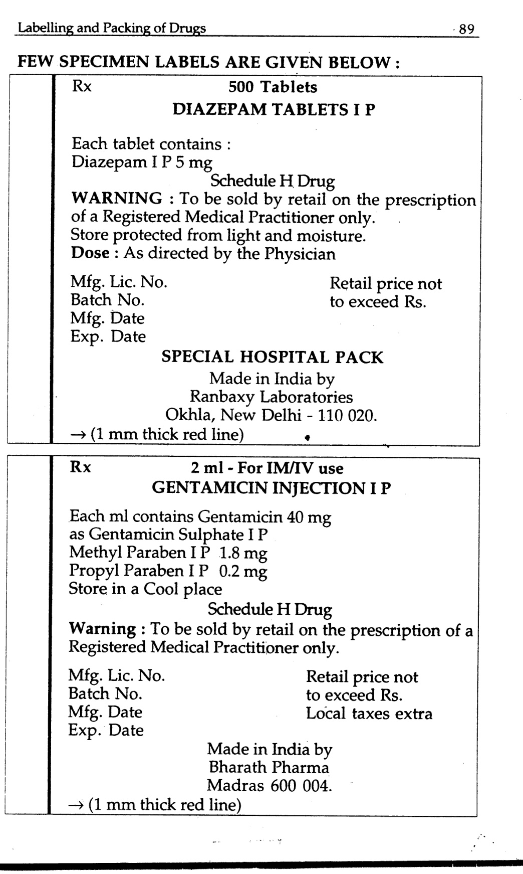

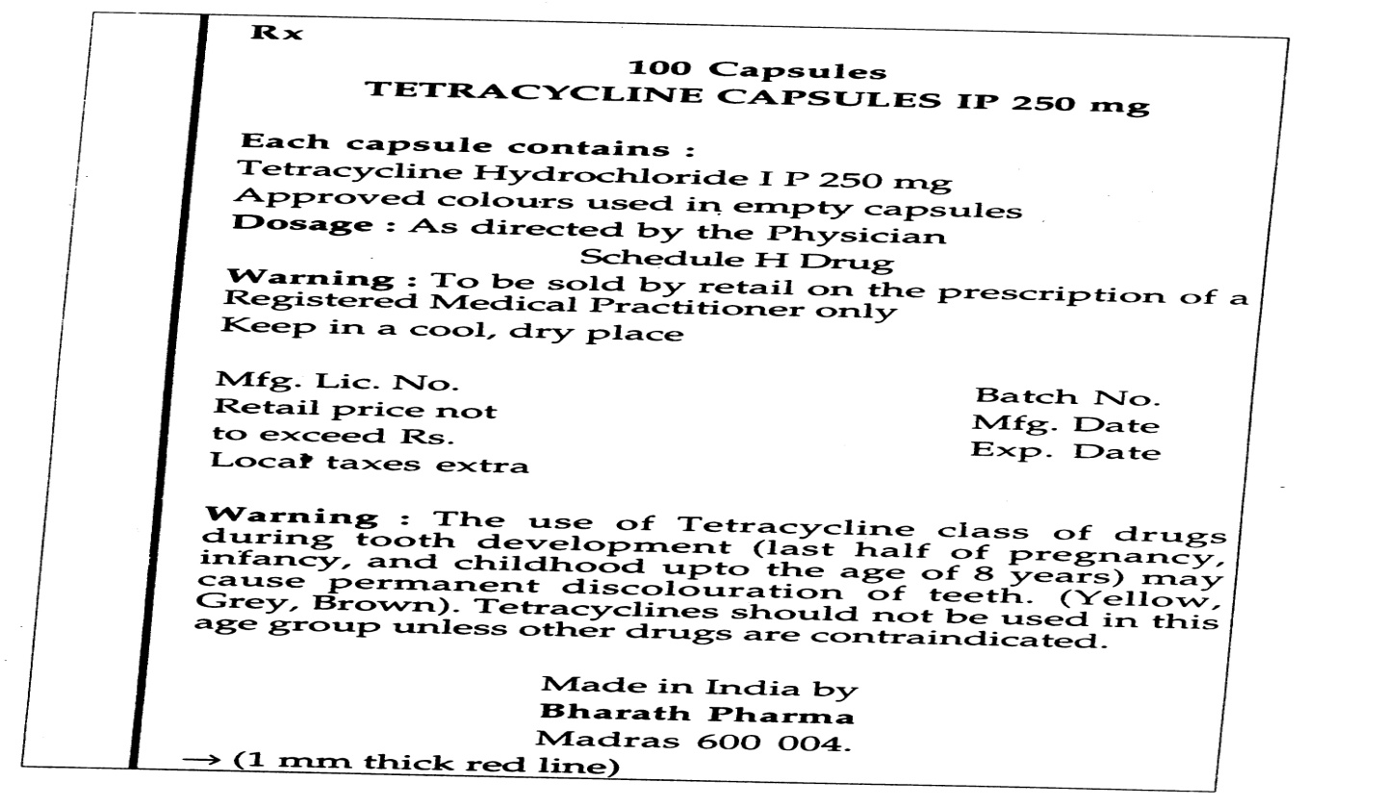

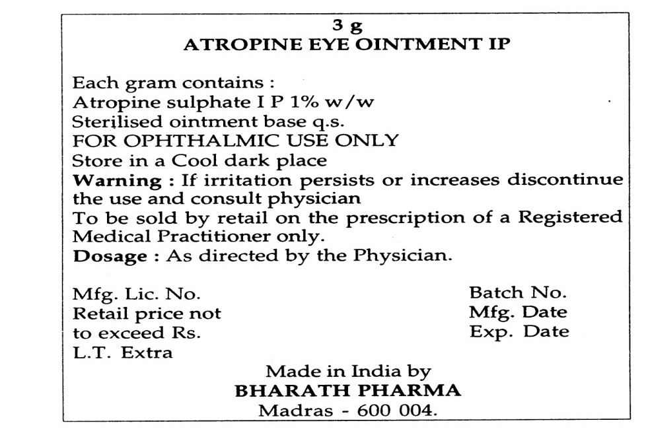

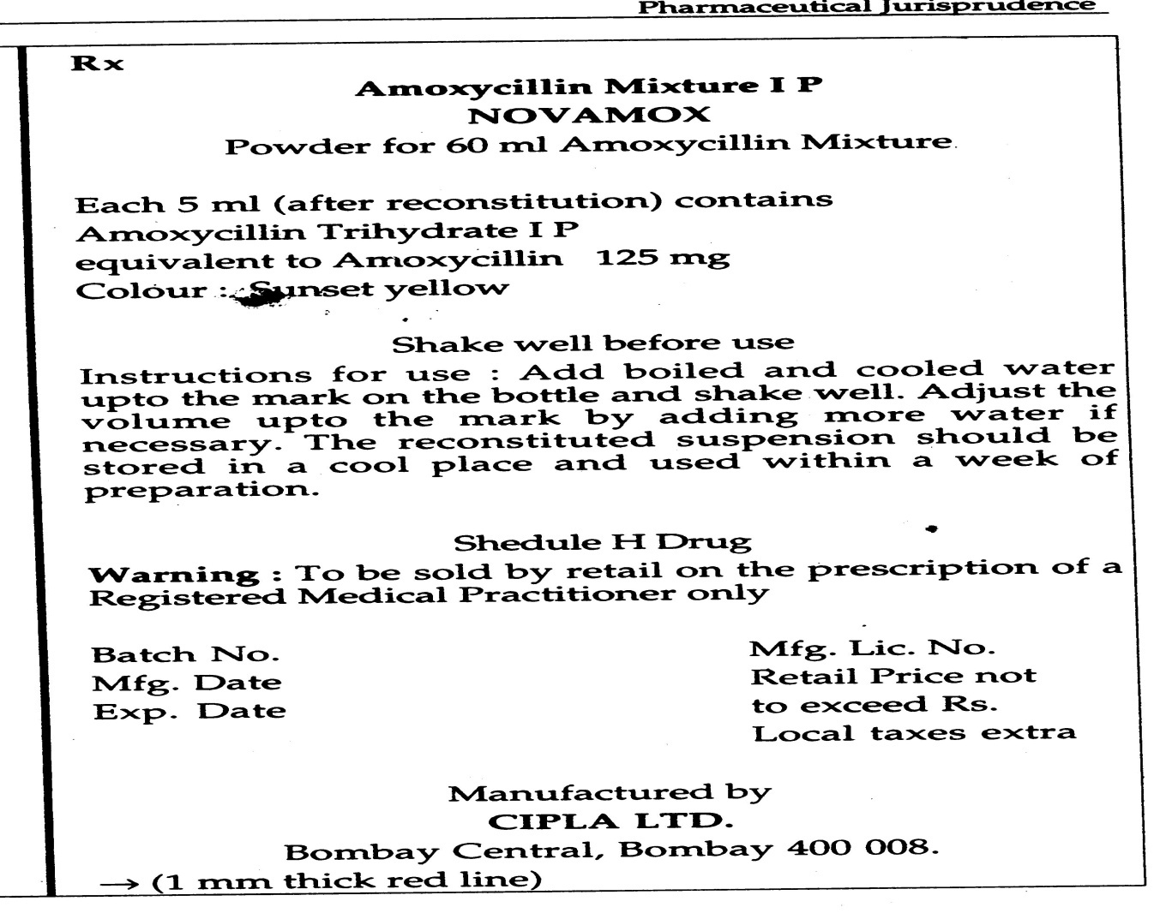

5

The drugs and magic remedies (objectionable advertisements) Act, 1954

Q. 1. How are the following defined according to the drugs and magic remedies(objectionable advertisements) Act:
- Advertisements
- Drugs
- Magic remedies
Ans: According to the drugs and magic remedies Act,
Advertisements include all notices, circulars, labels, wrappers or other documents and all announcements made orally or by means of producing or transmitting light, sound or smoke.
Drugs include:
- Medicines for the internal or external use of human beings or animals.
- Any substance intended to be used for or in the diagnosis, cure, mitigation, treatment or prevention of disease in human beings or animals.
- Any article, other than food, intended to affect the body of human beings.
- Any article, intended for use as a component of any medicine, substance or article
referred to above.
Magic remedies: Include talismans, mantras, kavachas and any other charm of any kind which
is alleged to possess miraculous powers for or in the diagnosis, cure, mitigation, treatment or prevention of any disease in human beings or animals or for affecting in any way the structure
or any organic function of the body of human beings or animals.

Q. 2. What kind of advertisements is prohibited under the Act?
Ans: The following classes or advertisements are prohibited to be made under the Act:
- Advertisements, relating to drugs, which are likely to lead to their use in the following ailments or conditions:
- For the procurement of miscarriage or prevention of conception in women.
- For the correction of menstrual disorders in women.
- For the Maintance or improvement of the capacity of human beings for sexual pleasure.
- The diagnosis, cure, mitigation, treatment or prevention of any disease, disorder
or condition specified in schedule J of the drugs and cosmetics rules, 1945.
- Advertisements which:
- Directly or indirectly gives false impression regarding the true character of the
drug.
- Make a false claim for the drug.
- Are otherwise false or misleading in any material particular.
- Advertisements relating to magic remedies claiming their efficacy foe any of the conditions outlined in (1) by persons, who purport to carry on the profession of administering magic remedies.

Q. 3. What types and classes of advertisements are exempted under the drugs and magic remedies (objectionable advertisements) Act?
Ans: Exempted advertisements:
The following classes of advertisements and displays are exempted from the purview of
the act and hence can be made without any prohibition:
- Sign boards or notices displayed by registered medical practitioner (RMP) indicating that treatment is undertaken for the disease or disorder, advertisements relating to which are otherwise prohibited.
- Books or treaties relating to the diseases or ailments which are otherwise prohibited to be advertised provided published from bonafide scientific or social standing.
- Advertisements sent confidentially, in the prescribed manner, to RMP’s. However, such advertisements should bear the following words on top, in a conspicuous manner: for the use of RMP or a hospital or a laboratory.
- Any advertisement relating to a drug printed or published by the government or by any person with the prior permission of the government.
- Advertisements, labels or set of instructions which are permitted under the drugs and cosmetics act or rules made thereunder.
The central government may also permit the advertisements of any drug which it feels
shall be in the interest of the public.
Advertisements exempted conditionally:
The following classes of advertisements have also been exempted conditionally:
Class of advertisement:
- Leaflets or literature accompanying packing of drugs.
- Advertisements of drugs in medical, pharmaceutical, scientific and technical journals.
Conditions:
- The advertisement contains only such information as is required for the guidance of registered medical practitioner in respect of matters relating to:
- Therapeutic indications of the drug.
- Its administration.
- Its dosage.
- Its side effects.
- The precautions to be observed in the treatment with the drug.
- The responsibility to prove that any claim made in the advertisement in respect of the
drug is not false, exaggerated or misleading, shall lie on the advertiser.

Q. 4. What kind of advertisements is prohibited to be imported or exported under the
drugs and magic remedies Act?
Ans: The following classes or advertisements are prohibited to be imported or exported under the Act:
- Advertisements, relating to drugs, which are likely to lead to their use in the following ailments or conditions:
- For the procurement of miscarriage or prevention of conception in women.
- For the correction of menstrual disorders in women.
- For the maintenance or improvement of the capacity of human beings for sexual
pleasure.
- The diagnosis, cure, mitigation, treatment or prevention of any disease, disorder or condition specified in schedule J of the drugs and cosmetics rules, 1945.
- Advertisements which:
- Directly or indirectly gives false impression regarding the true character of the
drug.
- Make a false claim for the drug.
- Are otherwise false or misleading in any material particular.
- Advertisements relating to magic remedies claiming their efficacy for any of the conditions outlined in (1) by persons, who purport to carry on the profession of administering magic remedies.
Any documents containing these advertisements are deemed to be goods of which
import or export has been prohibited under the sea customs Act, 1878.

Q. 7. What are the offences and penalties for contravention of any provision of the Act?
Ans: Contravention of any provision of the Act is punishable with imprisonment up to six months or fine or both on first conviction, and imprisonment up to one year or fine or both on any subsequent conviction. Any document, article or thing in respect of which the contravention is made can also be forfeited.
In case of contravention of the provisions of the Act by a company, every person who, at the time of the commission of the offence, was incharge of the company and was responsible for the conduct of its business, shall be deemed guilty of the offence, unless the can prove that the offence was committed without his knowledge and that he had exercised due diligence to prevent the commission of the offence.
Offences under the Act can be tried only in the courts in the courts of the presidency magistrates or magistrates of the first class.

6

The narcotic drugs and psychotropic substances Act, 1985

Q. 1. Define the following:
- Narcotic drug
- Controlled substance
- Opium
- Opium derivative
Ans: Narcotic drug Means coca leaf, cannabis (hemp), opium strew and includes all manufactured goods.
Controlled substanceMeans any substance which the central government may, having regard to the available information as to its possible use in the production or manufacture of narcotic drugs or Psychotropic substances or to the provisions of any international convention, by notification in the official gazette, declare to be a controlled substance.
Opium Means:
- The coagulated juice of the opium poppy.
- Any mixture, with or without any neutral material, of the coagulated juice of the opium poppy.
But does not include any preparation containing not more than 0.2 percent of morphine.
Opium derivative Means:
- Medicinal opium, that is, opium which has undergone the processes necessary to adapt it for medicinal use in accordance with the requirements of the Indian pharmacopoeia or any other pharmacopoeia notified in this behalf by the central government, whether in powder form or granulated or otherwise or mixed with neutral materials.
- Prepared opium, that is any product of opium by any series of operations designed to transform opium into a suitable for smoking and the dross or other residue remaining after opium is smoked.
- Phenanthrene alkaloids, namely morphine, codeine, thebaine and their salts.
- Diacetylmorphine, that is, the alkaloid also known as dia-morphine or heroine and its salts.
- All preparations containing more than 0.2 percent of morphine or containing any diacetyl morphine.

Q. 2. Describe briefly the operations which are totally prohibited under the narcotic drugs and psychotropic substances Act.
Ans: the following operations are totally prohibited under the narcotic drugs and psychotropic substances Act:
- Cultivation of any coca plant gathering of any portion of coca plant.
- Cultivation of opium poppy or any cannabis plant.
- Production, manufacture, import, possession, sale, purchase, transportion, warehousing, consumption, export, etc. of any narcotic drug or psychotropic substance, except for medical or scientific purposes and in the manner and to the extent provided or in accordance with the terms and conditions of a licence, permit or authorization, if
provided. However, nothing in this section shall apply to the export of poppy straw for decorative purposes.

Q. 3. Mention the penalties under the narcotic drugs and psychotropic substances Act, 1985 for the following offences:
- Contravention of provisions of the Act or rules in relation to poppy straw, coca plant and coca leaves, opium poppy and opium, prepared opium, manufactured drugs and psychotropic substances.
- Illegal import into India, export from India or transshipment of narcotic drugs and psychotropic substances.
- Illegal possession in small quantities for personal consumption or consumption of cocaine, morphine and diacetylmorphine.
- Attempt to commit an offence punishable under the Act.
- Preparation of an offence but where circumstances have prevented the commitment of the offence itself.
Ans: (i) and (ii) rigorous imprisonment for 10 to 20 years and a imprisonment for 15 to 30 years and a fine of not less than two lakh rupees on second and subsequent conviction:
(iii) Imprisonment upto 1 year or fine or both.
(iv) Same as that for commitment of the offence itself.
(v) Half of that for the commitment of the offence itself.

Drugs (price control) order, 1995

Q. 1. Define the terms bulk drug, celling price, dealer, drug, formulation and scheduled formulation.
Ans: Bulk drug Means any pharmaceutical, chemical, biological or plant product including its salts, esters, esters, stereo-isomers and derivatives, conforming to pharmacopoeial
or other standards specified in the second schedule to the drugs and cosmetics act, 1940, and which is used as such or as an ingredient in any formulation.
Ceiling price Means a price fixed by the government for scheduled formulations.
Dealer Means a person carrying on the business of purchase or sale of drugs, whether as
a wholesaler or retailer and whether or not in conjunction with any other business, and includes his agent.
Drug Includes:
- All medicines for internal or external use of human beings or animals and all substances intended to be used for, or in the diagnosis, treatment, mitigation or prevention of any disease or disorder in human beings or animals, including preparations applied on human body for the purpose of repelling insects like mosquitoes.
- Such substances, intended to effect the structure or any function of the human body or intended be used for the destruction of vermin or insects which cause disease in human beings or animals, as may be specified from time by the government by notification in
the official gazette.
- Bulk drugs and formulations.
Formulation Means a medicine processed out of, or containing one or more bulk drug
or drugs with or without the use of any pharmaceutical aids, for internal or external use
for or in the diagnosis, treatment, mitigation, mitigation and prevention of disease in
human beings or animals, but shall not include:
- Any medicine included in any bona fide ayurvedic (including siddha) or unani system of medicines.
- Any medicine included in the homeopathic system of medicine: and.
- Any substance to which the provisions of the drugs cosmetics Act, 1940 don’t
apply.
Schedule formulation Means a formulation containing any bulk drug specified in the
first schedule either individually or in combination with other drugs, including one or more than one drug or drugs not specified in the first schedule except single ingredient formulation based
on bulk drugs specified in the first schedule and sold under the generic name.

Q. 2. Give the formula for calculating the retail price of formulation according to the
latest drugs price control order.
Ans: The retail price of a formulation can be calculated in accordance with the following formula:
R.P. = (M.C. + C.C. +P.M. + P.C.) X (1 + MAPE/100) + E.D.
Where,
R.P. Means retail price:
M.C. Means material cost and includes the cost of drugs and other pharmaceutical aids used including overages, if any, plus process loss thereon specified as a norm time to time by notification in the official gazette in this behalf:
C.C. means conversion cost worked out in accordance with established procedures of costing and shall be fixed as a norm every year by notification in the official gazette in this
behalf:
P.M. means cost of the packing material used in the packing of concerned formulation, including process loss, and shall be fixed as a norm every year by notification in the official gazette in this behalf:
P.C. means packing charges worked out in accordance with the established procedures
of costing and shall be fixed as a norm every year by notification in the official gazette in this behalf:
MAPE (maximum allowable post-manufacturing expenses) means all costs incurred by manufacturer from the stage of ex-factory cost to retailing and includes trade margin for the manufacturer and it shall not exceed 100per cent for indigenously manufactured scheduled formulations:
E.D. means excise duty.
Provided that in the case of an imported formulation, the landed cost shall from the basis for fixing its price along with such margin to cover selling and distribution expenses including interest and importer’s profit which shall not exceed fifty percent of the interest and importer’s profit which shall not exceed fifty percent of the landed cost.
For the purpose of this provision, landed cost means the cost of import of formulation inclusive of customs duty and clearing charges.

8

The Medical Termination Of Pregnancy Act, 1971

An Act to provide for the termination of certain pregnancies by registered
medical practitioners and for matters connected therewith or incidental thereto
Be it enacted by Parliament in the Twenty-second Year of the Republic of India
as follows:
This Act may be called the Medical Termination of Pregnancy Act,
1971. It extends to the whole of India except the State of Jammu and
Kashmir.

Definitions
(a) "Guardian" means a person having the care of the person of a minor
or a lunatic;
(b) "Lunatic" has the meaning assigned to it in Sec.3 of the Indian Lunacy
Act, 1912
(c) "Minor" means a person who, under the provisions of the Indian
Majority Act, 1875 (9 of 1875), is to be deemed not to have attained his
majority,
(d) "Registered medical practitioner" means a medical practitioner who
possesses any recognized medical qualification as defined in Cl.(h) of
Sec. 2 of the Indian Medical Council Act, 1956 (102 of 1956), whose
name has been entered in a State Medical Register and who has such
experience or training in gynecology and obstetrics as may be
prescribed by rules made under this Act.

Q. 1 When Pregnancies may be terminated by registered medical practitioners.-

Answer- A pregnancy may be terminated by a registered medical practitioner,-
(a) where the length of the pregnancy does not exceed twelve weeks if such medical practitioner is, or
(b) where the length of the pregnancy exceeds twelve weeks but does not exceed twenty weeks, if not less than two registered medical practitioners are of opinion, formed in good faith, that,-
(i) the continuance of the pregnancy would involve a risk to the life of the
pregnant woman or of grave injury physical or mental health ; or
(ii) there is a substantial risk that if the child were born, it would suffer from such physical or mental abnormalities as to be seriously handicapped.

Explanation 1.-Where any, pregnancy is alleged by the pregnant woman to have
been caused by rape, the anguish caused by such pregnancy shall be presumed to
constitute a grave injury to the mental health of the pregnant woman.

Explanation 2.-Where any pregnancy occurs as a result of failure of any device
or method used by any married woman or her husband for the purpose of
limiting the number of children, the anguish caused by such unwanted pregnancy
may be presumed to constitute a grave injury to the mental health of the pregnant
woman.
(3) In determining whether the continuance of pregnancy would involve such
risk of injury to the health as is mentioned in sub-section (2), account may be
taken of the pregnant woman's actual or reasonable foreseeable environment.
(4) (a) No pregnancy of a woman, who has not attained the age of eighteen
years, or, who, having attained the age of eighteen years, is a lunatic, shall be
terminated except with the consent in writing of her guardian.
(b) Save as otherwise provided in C1.(a), no pregnancy shall be terminated
except with the consent of the pregnant woman.
4. Place where pregnancy may be terminated.-No termination of pregnancy
shall be made in accordance with this Act at any place other than,-
(a) a hospital established or maintained by Government, or
(b) a place for the time being approved for the purpose of this Act by
Government. 5. Sections 3 and 4 when not to apply.-

