
PHARMACEUTICAL CHEMISTRY II
SECOND YEAR DIPLOMA IN PHARMACY

CONTENTS

01 | ANTISEPTICS AND DISINFECTANTS | 4-5
02 | ANTIBIOTICS | 6-8
03 | ANTI-LEPROTIC DRUGS | 9-10
04 | ANTI-TUBERCULAR DRUGS | 11-12
05 | ANTHELMINTICS | 13-14
06 | SULPHONAMIDES | 15-16
07 | ANTI-MALARIAL DRUGS | 17-18
08 | ANTI-AMOEBIC DRUGS | 19
09 | ANTI-FUNGAL AGENTS | 20
10 | ANTI-NEOPLASTIC AGENTS | 21
11 | NARCOTIC ANALGESICS | 22-23
12 | ANTIPYRETICS ANALGESICS | 24-25
13 | NON-STEROIDAL ANTI-INFLAMMATORY DRUGS (NSAIDs) | 26-27
14 | SEDATIVES AND HYPNOTICS | 28-29
15 | ANALEPTICS | 30-31
16 | TRANQUILIZERS | 32-33
17 | ANTI-DEPRESSANTS | 34
18 | GENERAL ANAESTHETICS | 35-36
19 | LOCAL ANAESTHETICS | 37-38
20 | COAGULANT | 39
21 | ANTI-COAGULANT | 40
22 | HYPOGLYCEMIC AGENT | 41-43
23 | DIURETICS | 44-46
24 | HISTAMINE AND ANTI-HISTAMINE | 47-48
25 | DIAGNOSTIC AGENTS | 49
26 | STEROIDAL DRUGS | 50
27 | ADRENERGIC DRUGS | 51-52
28 | ADRENOLYTIC DRUGS | 53
29 | CHOLINERGIC DRUGS | 54-55
30 | ANTI-CHOLINERGIC DRUGS | 56-57

CHAPTER-1
ANTISEPTICS AND DISINFECTANTS
Antiseptics: - Antiseptics are the agents that destroy or kill or prevent the growth of the microorganism when applied to living tissues. They are applied in the form of mouthwashes, gargles, soaps, preparations for minor wound and burns.

Disinfectants: - These are the agents that kill vegetative bacteria when use on an inanimate (non-living) objects.

CLASSIFICATION  1) Phenols and related compounds  Ex: Phenol, Chlorocresol, Chloroxylenol.  2) Alcohol and Related compounds  Ex: Ethanol, Isopropyl alcohol.  3) Aldehyde  Ex: Formaldehyde  4) Carboxylic acid derivatives  Ex: Benzoic acid, Methyl P-hydroxy-benzoate.  5) Halophors  Ex: Povidone-iodine, chloramine-T.  6) Heavy metals  Ex: Silver sulphadaizine, Thiomersal  7) Quaternary ammonium compound  Ex: Benzalkonium chloride, Cetrimide.  8) Dyes  Ex: Proflavin, Brilliant green.  9) Miscellaneous  Ex: Nitrofurazone, Nitrofurantoin. | PROFLAVIN  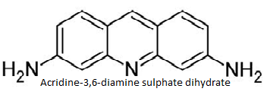  CHLOROCRESOL  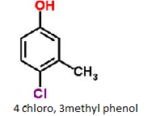

Properties | Proflavin | Chlorocresol
Physical Properties | Orange to red crystalline powder, odourless, soluble in water. | Colourless crystal characterstic odour soluble in hot water.
Stability & Storage | Affected by light & hygroscopic. Hence it is stored in tightly - closed light -resistant containers. | Oxidized by air or oxygen hence it is store in a tightly closed container.
Different Formulation | Proflavin creams | Chlorocresol solution.
Uses | It is used  - In treatment of infected wound.  - For dressing of wounds and burns  - For treatment of local infections of ear, mouth, throat and skin. | - It is a powerful bactericide and fungicide.  - It is used as preservative in creams & pharmaceutical preparations for external use.

CHAPTER -2
ANTIBIOTICS
Antibiotics are defined as substances produced by microorganisms which have the capacity of inhibit the growth or destroying other microorganisms. Some antibiotics having high degree of specificity, such that they are selectively effective either gram positive bacteria or gram negative bacteria or certain fungi or yeast are called as narrow spectrum antibiotics. Some antibiotics are effective on large number of pathogens and are called as broad spectrum antibiotics.
CLASSIFICATION  - B- lactum antibiotics (contains β lactum ring)  Ex: Benzyl penicillin, benzathine penicillin,Phenoxymethyl penicillin, ampicillin, cloxacillin, carbenicillin, cephalexin  - Non-lactum antibiotics (does not contain β lactum ring)  - Polypeptide antibiotics  Ex: Bacitracin  - Polyene antibiotic  Ex: Nyastatin, Hamycin, Amphotericin-B  - Aminoglycosides antibiotic  Ex: Gentamycin, Neomycin, Streptomycin.  - Macrolides and linomycins  Ex: Erythromycin, Clindamycin, Tetramycin,  Chlortetracycline.  - Steroidal antibiotics  Ex: Fusidic acid  - Nucleoside antibiotics  Ex: puromycin  - Other antibiotics  Ex: Chlormphenicol, Griseofulvin. |  |  | STRUCTURE  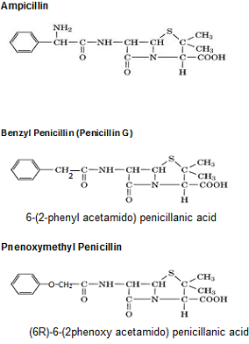
 | Penicillin is the first antibiotics discovered. It was first extracted from penicillin notatum. Along 30 penicillin have been isolated by the fermentation method using mixture of various stains. Penicillin contains β lactum ring, a 4-membered cyclic amide, is fused with thiazolidine ring so that the nitrogen atom and adjacent carbon atom are common to both rings. This gives bicyclic hetrocyclic system called penem
 | CLASSIFICATION  - Natural penicillin  Ex: Penicillin - G, Procaine Penicillin  - Semi synthetic penicillin  - Acid resistance penicillin.  Ex: Phenoxymethyl penicillin  - Penicillinase resistance penicillin  Ex: Cloxacillin  - Broad spectrum penicillin  Ex: Ampicillin, Carbencillin. | 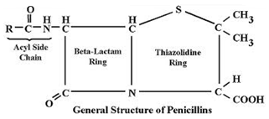

Properties | Benzyl Penicillin (Penicillin-G) | Phenoxymethyl penicillin | Ampicillin
Physical Properties | White crystalline powder, characteristic odour, soluble in water | White crystalline powder, odourless, bitter taste, freely soluble in alcohol | White crystalline powder, bitter taste, soluble in water.
Stability and storage | Stability of benzyl penicillin depends upon moisture content. If moisture content is less than 0.5% at room temperature, benzyl penicillin is stable for 2 to 3 years. Hence stored in tightly closed container and protects from moisture | Stored in tightly closed container | Unstable above 25ºC. Hence stored in tightly closed containers in a cool place or at a temperature not exceeding 25 degrees.
Formulation | Benzyl Penicillin injection, Benzyl Penicillin eye drop, Benzyl Penicillin eye ointment | Phenoxymethyl penicillin Capsule, Phenoxymethyl penicillin tablet, Phenoxymethyl penicillin oral suspension | Ampicillin Capsule, Ampicillin tablet, Ampicillin oral suspension, Ampicillin injection
Brand Names | Pentids, Crystapen, PAM. | Depen, Penitriad, Crystapen V | Roscillin, Ampillin, Ampipin
Uses | It is used to treat  - Syphilis  - Gonorrhea  - Pneumonia  - Pharyngitis  - Tetanus  - Diptheria  - Anthrax | It is used to treat  - Respiratory tract infection  - Urinary tract infection  - Bone and joints infections  - Meningitis | It is used to treat  - Respiratory tract infection  - Urinary tract infection  - Bone and joints infections  - Meningitis  - Syphilis  - Gonorrhea  - Pneumonia

Chapter - 3
Anti- Leprotic Drugs
Leprosy is a chronic infectious disease caused by mycobacterium leprae. The disease mainly affects the skin, the peripheral nerves, mucosa of upper respiratory tract and also the eyes. It multiply very slowly, symptoms can take as long as twenty years to appear. Untreated leprosy can cause progressive and permanent damage to skin, nerves limbs & eyes. The drug used for the treatment of leprosy is called as anti leprotic drugs.
CLASSIFICATION  - Sulphones  Ex : Dapsone, Solapsone  - Phenazine  Ex : Clofazimine  - Antituberclosis drugs  Ex : Rifampicin , Ethionamide  - Other antibiotics  Ex : Ofloxacin , Clarithromycin | STRUCTURE  Dapsone (DDS)  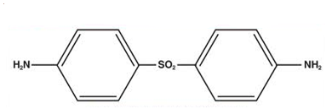  4,4- diamino diphenyl sulphone

Properties | Dapsone
Physical properties | White or creamy white crystalline powder, odourless, bitter taste and soluble in acetone and in dil. Mineral acids.
Stability & Storage | Pure dapsone is stable. But in the presence of trace of impurities and water, it is discoloured. Hence it is stored in well-closed light-resistant containers.
Formulation | Dapsone Tablet
Brand names | Dubronax, Acezone
Uses | - It is a drug of choice for leprosy  - It is used in the treatment of dermatitis  - In combination with trimethoprim or pyrimethamine, it is used to treat pneumonia

Chapter – 4
Anti-Tubercular Drugs
Tuberculosis or T.B. (Tubercle bacillus) is an infectious disease caused by various strains of mycobacterium usually mycobacterium tuberculosis. Tuberculosis usually attacks the lungs but can also affect other parts of the body. The classic symptoms are a chronic cough with blood-hinged sputum, fever, night-sweats and weight loss. The drug used for the treatment of tuberculosis is called as anti-tubercular drugs. Treatment is difficult and requires long courses of multiple antibiotics. Social contacts are also screened.
CLASSIFICATION  - P-amino salicylic acid(PAS) and Analogues  Ex: P-amino salicylic acid (PAS)  - Pyridine derivatives  Ex: Isoniazid(INH), Ethionamide  - Pyrazine derivatives  Ex: Pyrazinamide  - Ethylene diamine derivatives  Ex: Ethambutol  - Antibiotics  Ex: Rifampicin, Streptomycin, Cycloserine | ISONIAZID  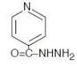  Pyridine-4-Carbohydrazide | ETHAMBUTOL  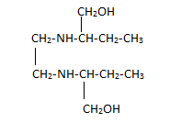  (+)N.N’-Bis{(R)-1-hydroxymethyl propyl}ethylenediamine
 | P-AMINO SALICYLIC ACID  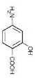  4-amino,2-hydroxy, benzoic acid | PYRAZINAMIDE  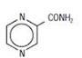  Pyrazine-2-Carboxamide

Properties | Isoniazid | P-amino salicylic acid(PAS) | Ethambutal | Pyrazinamide
Physical Properties | White crystalline powder, odourless and sweet taste followed by bitter taste. It is soluble in water. | Yellowish white crystal acidic taste, soluble in dilute nitric acid. | White crystalline powder, odourless and freely soluble in water. | White crystalline powder, odourless, bitter taste and soluble in ether and chloroform.
Stability and storage | Affected by light. Hence stored in tightly- closed light resistant containers. | Affected by air and light. Hence stored in tightly- closed light -resistant containers. | Stored in tightly closed containers. | Stored in tightly -closed containers.
Formulations | ISsoniazid Elixir, Isoniazid tablet, Isoniazid injection | Amino salicylic acid tablet, Amino salicylic acid capsule | Ethambutal tablet, Ethambutal powder | Pyrazinamide tablet
Brand Names | Cadizide, isonex, Rimpazid, Isocadipas | Idipas, Isopar, Benzapas | Albutol, Ly- boytol, Myambutol | Zinamide, Pyride, Pyrina-500
Uses | It is used in the treatment of  - Pulmonary tuberculosis  - Extrapulmonary lesions  - Lupus vulgaris | Treatment of tuberculosis in combination with Isoniazid and Streptomycin | Treatment of tuberculosis | Treatment of tuberculosis

Chapter- 5
Anthelmintics
Antihelmintics:- These are drugs that expel parasitic worms from the body, by either stunning or killing them. This includes both flat worms, e.g. Flukes and tapeworms and round worms, e.g.: Nematodes. They may also be called as vermifuges and vermicides.
CLASSIFICATION  - Halogenated hydrocarbons  Ex: tetrachloroethylene  - Halogenated phenols and biphenols  Ex: bithinol  - Dyes  Ex: gentian violet  - Piperazine and related compounds  Ex: piperazine citrate, diethylcarbamazine  citrate (DEC)  - Other hetrocyclic ring containing compounds  Ex: mebendazole, niridazole | PIPERAZINE  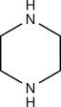  DIETHYLCARBAMAZINE  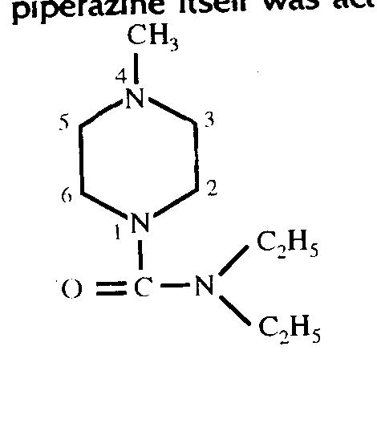  N,N-diethyl,4-methyl,piperazine-1-carboxamide
Properties | Piperazine | Diethyl Carbamazine
Physical Properties | Colourless crystal, characteristic odour, soluble in water | White crystalline powder odourles, bitter taste, soluble in water
Stability and storage | Affected by light. Hence stored in tightly -closed light- resistant containers | Stored in tightly - closed containers
Formulations | Peprazine elixir, Piperazine tablets | Diethyl Carbamazine Injections, Diethyl Carbamazine tablets
Brand Names | Wormicid, Anitpar, Helmacid | Filazine, Hetrazen
Uses | It is used to treat  - Roundworm infestation  - Pinworm infestations | It is used to treat  - Round worm infestation  - Filarial infection  - Loiasis infection

Chapter- 6
Sulphonamides / Sulpha Drugs
Sulphonamides are synthetic anti-microbial agent with wide spectrum activities affective against most gram positive and gram negative organisms. These drugs were the first efficient treatment to be employed systematically for the prevention and treatment of bacterial infection but as the microorganism have developed resistance to sulphonamides. The spectrum is reduced greatly.
CLASSIFICATION  - N₁ substituted Sulphonamides  (a)With a cyclic substituent  Ex: Sulphacetamide,Sulphaguanidine  (b) With hetrocyclic substituent  Ex: Sulphadiazine,Sulphamethoxazale  - N₄ substituted Sulphonamides  Ex: Sulphasalazine  - N₁ and N₄ substituted Sulphonamides  Ex: Pthayl Sulphathiazole, Succinyl sulphathiazole | 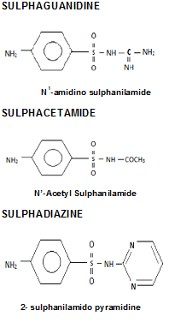

.
COTRIMOXAZOLE is a mixture of five parts of Sulphamethoxazole and one part of Trimethoprim. Sulphamethoxazole and Trimethoprim are bacteriostatics and when given alone bacterial resistance developed and needed higher dose produce toxic affects like Crystaluria.When combinations of these two drugs are given the antimicrobial activity was increased.
Cotrimoxazole is used in the treatment of
  - Genito-urinary tract infection b) Respiratory tract infection ( bronchitis, pneumonia ) c) Meningitis d) Enteric infections
Brand name: Septran, Ciplin
Formulations: Cotrimoxazole tablet (480mg), Cotrimoxazole Injection. , Cotrimoxazole mixtures

Properties | Sulphacetamide | Sulphadaizine | Sulphguanidine
Physical Properties | White or Yellowish crystalline powder, odourless and slightly soluble in aqueous alkaline solution and dilute mineral acids | White or Yellowish crystalline powder, odourless and slightly soluble in aqueous alkaline solution and dilute mineral acids | White or Yellowish crystalline powder, odourless and slightly soluble in aqueous alkaline solution and dilute mineral acids
Stability and Storage | Affected by heat and air. Hence they are stored in a tightly- closed light- resistant containers. | Affected by heat and air. Hence they are stored in a tightly- closed light- resistant containers. | Affected by heat and air. Hence they are stored in a tightly- closed light- resistant containers.
Different Formulation | Eye drops, Eye ointments | Tablet, Injection | Tablet
Uses | To treat eye infection | Treatment of meningitis, Treatment of UTI | Treatment of local intestinal infection

Chapter -7
Anti-malarial Drugs
Malaria is a disease caused by parasite protozoa which belong to the genus Plasmodium, transmitted through the bite of female anopheles mosquito. Four plasmodium species responsible for causing malaria in human being are P.falciparum, P.ovale, P.vivax and P.malariae.
The characteristic symptoms of malaria are chills, fever, and sweating and body pain. Anti-malarial are the drugs which prevent or cure malaria.
CLASSIFICATION  - Cinchona alkaloids  Ex: Quinine  - 4-amino quinolines  Ex: Chloroquine, amodiaquine  - 8-aminoquinolines  Ex: Primaquine  - Acridines  Ex: Mepacrine  - Biguanidines  Ex: Proguanil  - Pyrimidine derivatives  Ex: Pyrimethamine, Trimethoprim  - Miscellaneous  Ex: Prontosil, Mefloquine, Dapsone | 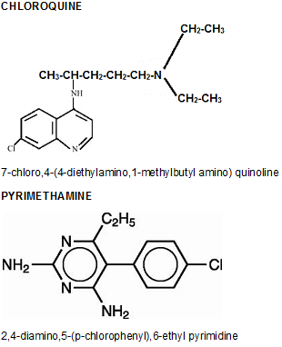

Properties | Quinine | Chloroquine | Pyrimethamine
Physical properties | Yellow crystalline powder, odourless, bitter taste, soluble in alcohol, dil. Acids | White crystalline powder, odourless, bitter taste, soluble in water | White crystalline powder, odourless, tasteless, soluble in mineral acid.
Stability and storage | Affected by light. Hence it is stored in well -closed light- resistant containers | Affected by light. Hence it is stored in well -closed light- resistant containers | Affected by light. Hence it is stored in well -closed light- resistant containers
Formulation | Quinine tablet, Quinine injection | Chloroquine tablet, Chloroquine injection | Pyrimethamine tablet, Pyrimethamine injection
Brand name | Vigotab, Larigo | Ciplaquine, Nivaquine | Pyralfin, Daraprim, Onli-2
Uses | a) To treat severe and complicated malaria caused by plasmodium falciparum.  b) To treat cerebral malaria  c) To relieve muscle cramps | a) To suppress and cure malaria  b) To treat amoebic hepatitis  c) To treat rheumatoid arthritis | To treat malaria

Chapter - 8
Anti-Amoebic Drugs
Amoebiasis is a protozoal disease caused by Entamoeba histolytica. Amoebiasis is due to poor hygienic conditions and is transmitted by the faecal-oral route and symptoms can range from mild diarrhea to dysentery with blood and mucosa in stool. Drugs are used for the treatment of amoebiasis is called anti-amoebic drugs.
CLASSIFICATION  - Alkaloids  Ex: emetine  - Amaroids  Ex: quassin  - Antibiotics  Ex: Paramomycin  - Quinoline derivatives  Ex: Iodoquinol, Clioquinol  - Heterocyclic compounds  Ex: Diloxanide, metronidazole  - Organometallic compounds  Ex: Acetarsol | 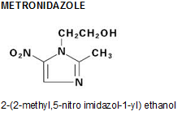

Properties | Metronidazole
Physical Properties | White crystalline powder, slight odour, bitter and saline taste, soluble in alcohol.
Stability and Storage | Affected by light. Hence stored in air- tight light- resistant containers.
Formulation | Metronidazole Tablet, Metronidazole injections, Metronidazole suppositories.
Brand name | Flagyl, metroquin, metroquinol, Albendazole
Uses | Treatment of amoebic dysentery, amoebic hepatitis.

Chapter - 9
Anti- Fungal Agent
Disease caused by fungus is known as mycosis. Mycoses are common and a variety of environmental and physiological conditions can contribute to the development of fungal diseases. People are at risk of fungal infections when they are taking strong antibiotics for a long period of time because antibiotics kill not only damaging bacteria, but healthy bacteria as well. This alters the balance of microorganisms in the mouth, vagina, intestines and other places in the body, and results in an overgrowth of fungus.
Individual with weakened immune systems are also at risk of developing fungal infections. This is the case of people with HIV/AIDS, people under steroid treatments, and people taking chemotherapy. People with diabetes also tend to develop fungal infections.
Mycoses are classified according to the tissue levels initially colonized
1 Superficial mycoses:- Superficial mycoses are limited to the outermost layers of the skin and hair
2 Subcutaneous mycoses:- Subcutaneous mycoses involve the dermis, subcutaneous tissues, muscle and fascia.
3 Cutaneous mycoses:-Cutaneous mycoses extend deeper into the epidermis, and also include invasive hair and nail diseases.
4 Systemic mycoses due to primary pathogens:- Systemic mycoses due to primary pathogens originate primarily in the lungs and may spread to many organ systems
5 Systemic mycoses due to opportunistic pathogens:-Systemic mycoses due to opportunistic pathogens are infections of patients with immune deficiencies, who would otherwise not be infected. Examples of immunocompromised conditions include AIDS, alteration of normal flora by antibiotics, immunosuppressive therapy, and metastatic cancer.

Anti fungal agents are used to treat variety of fungal infections. Some of antifungal agents are active orally while others are mostly applied in the form of ointments, creams, liniments, lotions, suspension etc

CLASSIFICATION OF ANTI-FUNGAL DRUGS

1 Topical antifungal agents:- Ex: Nyastatin, Hamycin, Tolnaftate
2 Systemic antifungal agents :- Ex: Griseofulvin, Amphotericin-B
3 Official fatty acid:- Ex: Undecylenic acid

Chapter -10
Anti-Neoplastic Agents
Anti-neoplastic agents are the medical term for cancer or tumour. Cancer is defined as a rapid proliferation of abnormal cell of any tissue, leading to the dearrangment of normal body functions. Cancer is not a disease but a group of diseases affecting different organs and system of the body.

A cancer cell arises from mesodermal cells (which form bone, muscles, cartilages and tissues) is called sarcoma, and if it arises from endoderm cells (which form intesti8nal system and its associated organs) and ectoderm cells (which form skin, and appendages and nerve tissue) is called carcinoma. Leukemia and polycythemia are the types of blood cancer.

The agent which causes cancer is known as carcinogenic agents.

Cancer is more difficult to cure than bacterial infections. The drugs which are used in the treatment of cancer is known as anticancer drugs. The therapy which is utilized today is use of ionizing radiation, surgery and use of chemotherapeutic agents.

CLASSIFICATION OF ANTI-CANCER DRUGS

1 Alkylating agents:- Ex: Chlorambucil, Busulfan, Melphalan, Decarbazine
2 Antibiotics:- Ex: Actinomycin-D, Mitomycin-C, Daunorubicin
3 Antimetabolite agents:- Ex: Methotrexate, Mercaptopurine, Azothiopurine, 5-Flurouracil
4 Hormones:- Ex: Promostanalone Propionate, Androgens, Estrogens, Progestins
5 Plant products:- Ex: Vincristine, Vinblastine
6 Enzymes:- Ex: L-Asparginase
7 Miscellaneous:- Ex: Hydroxyurea

Chapter - 11
Narcotic Analgesics
Narcotic agents are potent analgesics which are used to relieve moderate to severe pain. Analgesics are selective central nervous system depressants used to relieve pain. The term analgesic means "without pain". Even in therapeutic doses, narcotic analgesics can cause respiratory depression, nausea, and drowsiness. Long term administration produces tolerance, psychic, and physical dependence called addiction.
The first narcotic analgesic discovered was morphine, which was isolated from opium. Morphine is used :
- For control of moderate to severe pain b) To suppress cough c) As a pre-anesthetic medication
- To treat diarrhoea

CLASSIFICATION  - Naturally occurring:  - Morphine and its analogues  Ex: Morphine, Codeine  - Totally Synthetic drugs:S  - Morphinan analogues  Ex: Levorphanol  - Benzomorphan analogues  Ex: Pentazocin  - 4-phenylpiperidine analogues  Ex: Pethidine  - Phenyl propylamine analogues.  Ex: Methadone | STRUCTURE  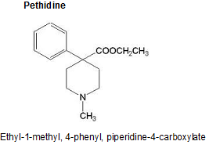

Properties | Pethidine
Physical Properties | White crystalline powder, odourless, bitter taste, soluble in water, alcohol and chloroform.
Storage and Stability | Affected by light. Hence it is stored in well - closed light - resistant containers.
Formulaton | Pethidine injection, Pethidine tablet.
Brand names | Pathilorphan, pethanol; Algil, Alodan, Dispadol, Dolantin
Uses | It is used:  - To relieve moderate to severe pain (spastic condition of intestine, uterus, bronchi, urinary bladder)  - As apre-anaesthetic medication  - As an obstetrical analgesic ( analgesic during labour)

Chapter - 12
Antipyretics Analgesics
Pyrexia is a condition where body temperature has been raised above normal. The rise in temperature may be due to infection or other diseases. The drugs which lower the raised (elevated) body temperature and bring it to normal are called antipyretics.
The drugs which relief from low intensity pain is called analgesic. Most of the drugs having both analgesic and antipyretic activities. Antipyretic analgesic are also called febrifuges or non narcotic analgesic
CLASSIFICATION  - Aniline and P-amino phenol derivatives  Ex: Acetanilide, Paracetamol  - Salicylic acid derivatives  Ex: Aspirin  - Pyrazole derivative  Ex: Analgin, Antipyrin | 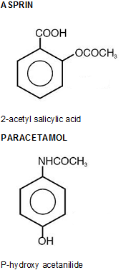

Properties | Paracetamol | Aspirin
Physical Properties | White crystalline powder, odourless, bitter taste, soluble in alcohol | White crystalline powder, odourless, bitter taste, slightly soluble in water and freely soluble in alcohol
Stability and storage | It is stored in well - closed light - resistant containers | Stable in air but slowly hydrolysed in presence of moisture. Hence stored in tightly closed containers
Formulation | Paracetamol tablets Paracetamol Elixirs | Aspirin tablets Aspirin dispersible tablets
Brand name | Crocin, Calpol, Metacin, Dolo | Disprin, Sprin
Uses | It is used as  - Antipyretic  - Analgesic  - Antirheumatic | - Used to relieve from mild to moderate pain like body pain, headache and toothache.  - To treat gout

Chapter - 13
Non-Steroidal Anti-Inflammation Drugs (NSAIDS)
The drugs which are used to reduce inflammation, and pain arising from it are called as anti-inflammatory agents. They are used in inflammatory conditions like arthritis, rheumatism, rheumatoid arthritis etc. They are also be useful in headache and migraine, neuralgia, toothache, dysmenorrhoea etc
CLASSIFICATION  - Salicylic acid derivatives  Ex: Aspirin.  - Anthranilic acid derivatives  Ex: Mefonamic acid  - Acetic acid derivatives  Ex: Diclofenac  - Indole derivatives  Ex: Indomethacin  - Propionic acid derivatives  Ex: Ibuprofen  - Pyrazolones  Ex: Phenyl butazone,  Oxyphen butazone  - Oxicams  Ex: Piroxicam  - Benzotriazines  Ex: Azapropazone | INDOMETHACIN  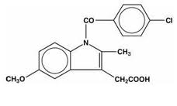  1-(P-chlorobenzoyl),5-methoxy,2-methyl indol-3-yl-acetic acid  PHENYLBUTAZONE  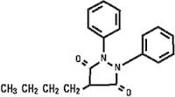  4-n-butyl,1,2,diphenyl,pyrazolidine 3,5-dione

Properties | Indomethacin | Phenyl butazone
Physical properties | Brownish or yellowish crystalline powder, odourless, bitter taste, soluble in alcohol | White crystalline powder, odourless, bitter taste, soluble in chloroform.
Stability and storage | Stored in well closed light resistant container. | Stored in well closed containers.
Formulations | Indomethacin Capsules, Indomethacin Suppositories | Phenyl butazone Tablet, Phenyl butazone Suppositories
Brand Names | Ciplacid, Indometh, Indocap | Painil, Butadex, Arcure,
Uses | It is used in the treatment of  - Rheumatoid arthritis,  - Osteoarthritis  - Acute gout.  - Dysmenorrhoea | It is used in the treatment of  - Rheumatoid arthritis,  - Osteoarthritis  - Acute gout.  - Dysmenorrhoea

Chapter - 14
Sedatives and Hypnotics
Sedatives are the drugs which depress central nervous system and used in relief of tension, anxiety and restlessness.
Hypnotics are the drugs which depress central nervous system and produce sleep resembling like natural sleep. They are used to overcome insomnia (sleeplessness).

CLASSIFICATION  - Barbiturate  - Long acting barbiturate (6 hrs or more)  Ex: Barbitone, Phenobarbitone  - Intermediate barbiturate (3 to 6 hrs)  Ex: Butabarbitone  - Short barbiturate (less than 3 hrs)  Ex: Cyclobarbitone  - Ultra short barbiturate (1/2 to 1 hrs)  Ex: Thiopentone sodium  - Non-Barbiturate  - Benzodiazepine  Ex: Nitrazepam, Diazepam  - Amides and imides  Ex: Glutethemide, methyprylone  - Alcohol and its derivatives  Ex: Triclofos sodium  - Aldehyde and derivatives  Ex: Paraldehyde  - Miscellaneous  Ex: Bromides, Promethazine,  Diphenhydramine | PHENOBARBITONE  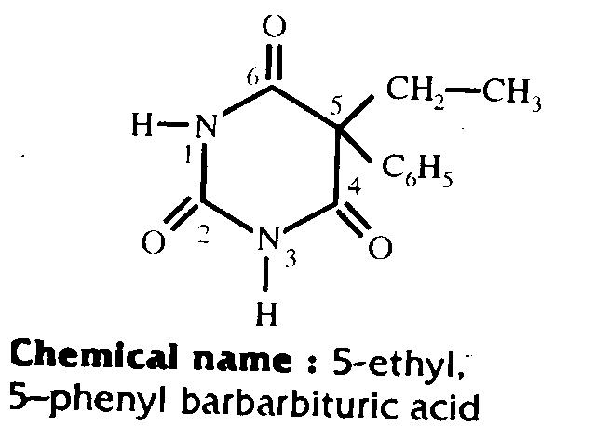  GLUTETHEMIDE  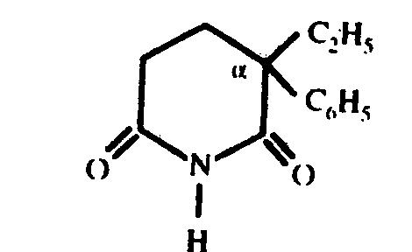  α-ethyl, α-phenyl glutarimide

Properties | Phenobarbitone | Glutethemide
Physical Properties | White crystalline powder, odourless, bitter taste and soluble in alcohol | White powder, odourless and bitter taste
Stability and storage | It is a stable compound. Hence stored in well - closed containers. | Affected by air, moisture and light. Hence it is stored in tightly - closed light - resistant containers.
Formulations | Phenobarbitone tablet,  Phenobarbitone capsule,  Phenobarbitone elixirs,  Phenobarbitone injection | Glutethemide Tablet,  Glutethemide Capsule
Brand Names | Gardenal, Phenytal | Doriden
Uses | - Used as sedatives and hypnotics.  - Used to treat grandmal and  psychomotor epilepsy.  c) Used to treat Neonatal jaundice. | Used as sedative and hypnotics

Chapter 15
Analeptics (C.N.S stimulants)
An analeptic is a drug which stimulates the central nervous system. The term analeptic specially refers to a respiratory analeptic a drug that acts on central nervous system to stimulate the breathing muscles, improving respiration.
CLASSIFICATION  - Naturally occurring drugs  - Alkaloids  - Xanthine derivatives  Ex: Caffeine, theophylline  - Other alkaloids  Ex: Strychine  - Synthetic derivatives  Ex: Nikethamide (coramaine)  - Miscellaneous  Ex: Dexamphetamine, Cocaine,  Atropine | CORAMINE (NIKETHAMIDE)  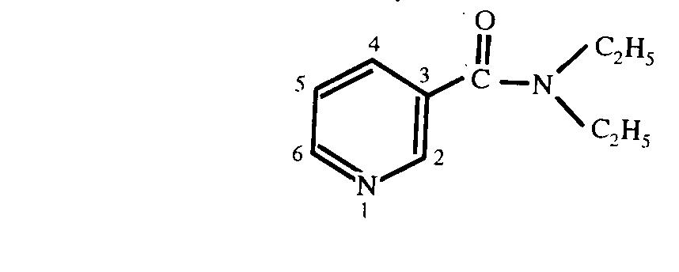  N,N diethyl pyridine 3 carboxamide  CAFFEINE  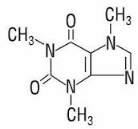  1,3,7 tri methyl xanthine

Properties | Caffeine | Nikethamide (Coramine)
Physical Properties | White crystalline powder, odourless, bitter taste, soluble in water | Slightly yellow oily liquid, faint aromatic odour and slightly bitter taste. It is miscible with water, alcohol and ether.
Stability and storage | It is decomposed by strong solution of caustic alkalies, its salt are decomposed by water. Hence it is stored in tightly - closed containers. Label should bear whether it is anhydrous or monohydrate. | It is affected by light. Hence stored in tightly - closed light - resistant containers.
Formulation | Aspirin and caffeine tablets,  caffeine and sodium benzoate tablet,  caffeine citrate tablet,  caffeine iodine tablet | Nikethamide injection
Brand Names | Anacin, coldarin, Powerin | Coramine, Nikethyl
Uses | - It is C.N.S stimulant and it is used:  - To enhance mental activity.  - To get relief from fatigue and mild depression.  - To cause insomnia in moderate dose.  - It has mild diuretic activity.  - It is generally given in combination with aspirin or codeine for analgesic activity.  - It also stimulates respiratory centre. | It is used as respiratory stimulants.
Chapter - 16
Tranquilizers
Tranquilizing agents are drugs which produce CNS depression and are used to reduce excitation, agitation, aggressiveness, worry and tension. These types of agents are also called as neurosedative or calming agents.
CLASSIFICATION  1 Phenothiazine derivatives  Ex: Chlorpromazine,  2 Ethylene diamine  Ex: Mepyramine, antazoline  3 Alkyl amines  Ex: Pheniramine, Chlorphenerimine  4 Phenothiazine derivatives  Ex: Promethazine  5 Piperazine derivatives  Ex: Meclazine, Buclizine  6 Miscellaneous  Ex: Cyproheptadine | HALOPERIDOL  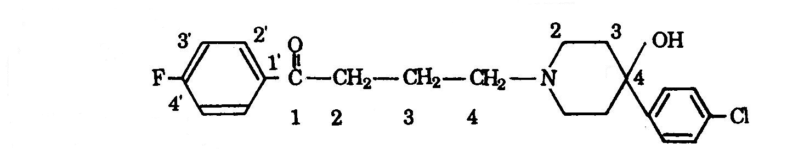  CHLORPROMAZINE DIAZEPAM  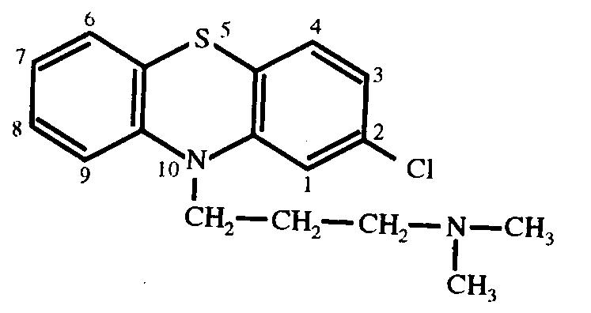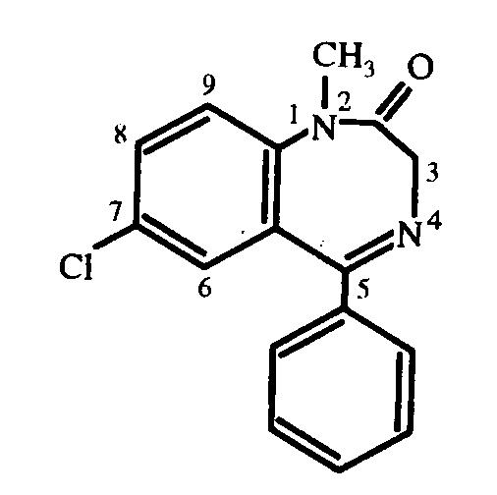

Properties | HALOPERIDOL | CHLORPROMAZINE | DIAZEPAM
Physical properties | Yellowish white microcrystalline powder, odourless, tasteless, soluble in alcohol. | White or cream coloured powder with slight odour, bitter taste, soluble in water and alcohol. | Yellowish white crystalline powder, odourless, tasteless, soluble in water, alcohol.
Stability and storage | Stored in well closed containers | Affected by light. Hence it is stored in well -closed light- resistant containers | Affected by moisture and light. Hence it is stored in well -closed light- resistant containers
Formulation | Haloperidol tablet, Haloperidol injection, Haloperidol capsules, Haloperidol elixir | Chlorpromazine tablet, Chlorpromazine injection, Chlorpromazine elixir | Diazepam tablet, Diazepam injection, Diazepam capsules, Diazepam elixirs
Brand name | Halidol, Trancodol | Copamide, Largactil, Chlorozine | Calmpose, Sedanite
Uses | 1) It is a major tranquilliser and used to treat acute schizophrenia, mania, hypomania, behavioural disturbances, severe anxiety, and childhood development disorders.  2) It is an antiemetic (to control nausea and vomiting) | 1) It is used to treat acute schizophrenia, mania, hypomania.  2) It is an antiemetic (to control nausea and vomiting)  3) It has local anaesthetics property.  4) It also reduces salivary and gastric secretion.  5) It is a vasodilator | It is used:  1) For management of anxiety and tension states.  2) For management of acute alcoholic withdrawal  3) As an adjunct for relief of skeletal muscle spasm  4) Parenterally,  a) to treat epilepsy  b) to produce sedation  c) to treat excitation states
Chapter - 17
Anti depressants
Antidepressants are the drugs which counteract or overcome mental depressant. These drugs are therapeutically useful in variety of cases pertaining to mentally ill patient. It is believed that mental depression occurs due to disturbance in the level of biogenic amines. Antidepressant drugs counteract mental depressant by balancing these amines in the brain.
CLASSIFICATION  1 Typical tricyclic antidepressants  - Iminodibenzyl derivatives:- Ex: Imipramine  - Dibenzoxepines:- Ex: Doxepine  - Benzocycloheptanes and related compounds:- Ex: Amitriptyline, nor-triptyline  2 MAO Inhibitors  - Hydrazides:- Ex: Phenezine  - Non-hydrazides:-  - Cyclopropylamines:- Ex: Tranylcypromine  - Sympathomimetics:- Ex: Dextramphetamine  3 A typical antidepressants:-  Ex: Dibenzipine, Iprindole  4 Miscellaneous:  - Β-adrenoreceptor agonist:- Ex: Salbutamol  - Thyrotropin:- Ex: Thyrotropin-Releasing-  Hormone (TRH) | STRUCTURE  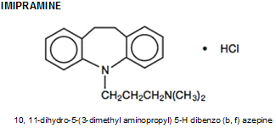  Stability and storage: Affected by light. Hence stored in tightly – closed, light – resistant containers.  Uses: It is used to treat:  - Depressive illness  - Anxiety disorders  - Nocturnal enuresis in children  - hyperactivity and attention deficit  - Catalepsy  - Allergic conjunctivitis

Chapter - 18
General Anesthetics
General anaesthetics (GAs) are the CNS depressant drugs that produce a reversible loss of all sensations and consciousness.
CLASSIFICATION  Based upon route of administration:  - Volatile and gaseous anaesthetics administered by inhalation  - Gases  - Inorganic gases  Ex: Nitrous oxide (N₂0)  - Hydrocarbons  Ex: Cyclopropane, Ethylene  - Volatile liquids  - Halogenated hydrocarbons  Ex: Halothane, trichloroethylene  - Ether  Ex: Diethyl ether  - Fixed anaesthetics administered intravenously  - Ultra short action barbiturates  Ex: Methohexital sodium,  thiopental sodium  - Miscellaneous compound  Ex: Ketamine | HALOTHANE  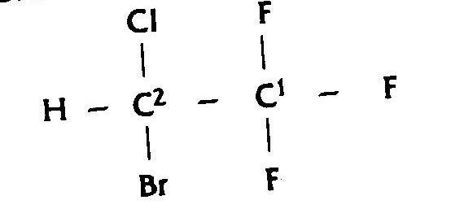  2-bromo,2-chloro, 1,1,1-trifluro ethane  CYCLOPROPANE  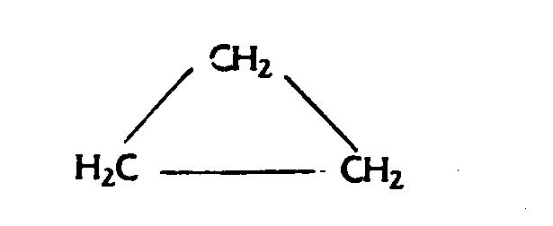  DIETHYL ETHER  CH₃-CH₂-O-CH₂-CH₃

Properties | Diethyl ether | Cyclopropane | Halothane
Physical properties | It is a colourless liquid, characteristics odour, and sweet burning taste. It is very volatile and inflammatory and forms explosive mixture with air. | It is a colorless inflammable gas having characteristics odour. It is a inflammable and form explosive mixture with air. | Colorless mobile liquid slightly soluble in water. It is non inflammable and does not form explosive mixture with air.
Stability & Storage | It is oxidized with atmospheric oxygen and it is affected by light. Hence it is stored in a tightly - closed, light - resistant container in a cool place and label should bear:  - Very inflammable  - Do not use near open flame or heat source.  - Name and proportion of stabilizer. | It is stored in metal cylinder designed to hold compressed gases and kept in a cool room free from inflammable material. The whole cylinder is painted orange and should be stenciled with the name of symbol {C₃H₆}. | It is decomposed slowly or exposure to light. It is also affected by air in presence of mixture it attack lead, glass, aluminium, but not cooper, plastic, rubber.  Hence it is tightly closed in a light resistant container.
Uses | Used as general anesthetic. | Used as general anesthetic. | Used as general anesthetic.

Chapter - 19
Local Anesthetics
These are drugs which produces reversible loss of sensation in limited area when applied, without loss of consciousness. They act by blocking the conduction of sensory nerve impulse near to the site of their application or injuries. Local anesthetics are used for temporary relief of pain in surgical procedure dental manipulation and injuries.
CLASSIFICATION  - Ester  - Ester of benzoic acid.  Ex: cocaine  - Ester of Para ammonia benzoic acid  Ex: procaine, benzocaine.  - Amides  - Anilide amides  Ex: xylocaine (Lidocaine or Lignocaine)  - Non – anilide amides  Ex: chinchocaine  - Miscellaneous  Ex: phenol, eugenol, benzyl alcohol. | STRUCTURE  PROCAINE  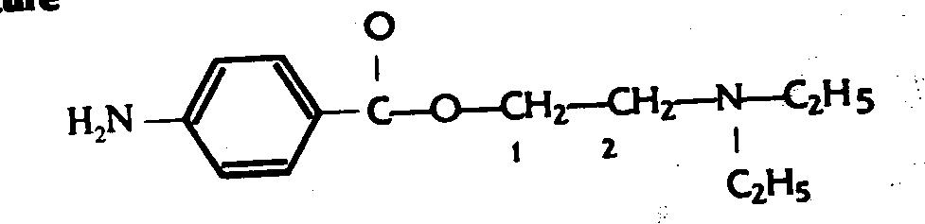  2-diethylamino ethyl,4-amino benzoate  LIGNOCAINE (LIDOCAINE OR XYLOCAINE)  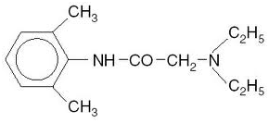  N-diethylamino acetyl 2,6-xylidine

Properties | Procaine | Lignocaine
Physical properties | White crystalline powdered, odourless and bitter in taste. It is freely soluble in alcohol and H₂O. | White crystalline powder bitter in taste soluble in H₂O and alcohol.
Stability and storage | Aqueous solution is most stable at pH 3.5. Hence it is stored in well - closed light - resistant containers. | It is very stable compound. Hence stored in a well closed container.
Formulation | Procaine and adrenaline injection. | Lignocaine injection, Lignocaine gels, Lignocaine eye drops.
Brand name | Novocaine, planocaine. | Otek, Otosil, Trox.
Uses | - Used as a local anaesthetics. | - Used as a local anaesthetics.  - It is also used for prevention and treatment of cardiac arrhythmias.

Chapter - 20
Coagulant
Coagulants: These are the substances which promote coagulation and are indicated in the treatment of severe hemorrhagic conditions.
Examples: Thrombin, Menadione
THROMBIN  It is a sterile protein substances prepared from human plasma and is freeze dried. Thrombin is affected by air heat and light. Hence it is a stored in the atmosphere of nitrogen in glass container which is sealed so as to prevent from micro organisms and moisture. The container kept at a temperature2 – 8^{O}C and protected from light.  Uses : It is used as an coagulant:  - Topically to control mirror bleeding , due to  superficial cut and injuries.  b) Orally to prevent gastro intestinal bleeding. | MENADIONE  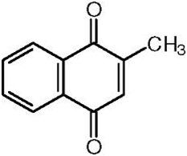
USES OF MENADIONE: it is used
- To treat haemorrhage due to excessive dosing with anticoagulant.
- To prevent and cure of neonatal haemorrhage.
- To treat vitamin K deficiency.
As radiosensitiser to treat cancer.

Chapter - 21
Anti- Coagulant
Anticoagulants are the drugs used to reduce the coagulation of blood. Anticoagulant agents are usually administered patient with acute myocardial infarction and the one undergoing treatment of pulmonary and venous thrombosis.
CLASSIFICATION
- Parentral anticoagulant
Ex: Heparin
- Oral anticoagulant
Ex: warfarin sodium, phenindione.

HEPARIN is a mixture of mucopolysaccharides of molecular weight ranging from 3000 to 40000.
Source: Lung of intestinal mucosa of ox, pig or sheep.
Stability & storage: The aqueous solutions are stable for at least 7yrs at pH 7 to 8. It is stored in sealed container to
protect from microorganisms and moisture
Formulations: Heparin injection.
Brand name: Beparine.
Uses: To prevent post operative deep venous thrombosis.
To prevent clotting during open heart surgery.

WARFARIN SODIUM: is a oral anticoagulant.
Properties: warfarin is odourless and has bitter tast,e soluble in alcohol and water.
Stability & storage: warfarin is discoloured by light and air. Hence it is stored in tightly closed light resistant container.
Formulations: warfarin tablet.
Brand name: sofarin
Uses: To prevent post operative venous thrombosis.
To prevent myocardial infractions.
Used as rodenticides.

Chapter - 22
Hypoglycemic Agent
Hypoglycemic agents are the drugs which are used to lower the blood sugar level. They are used to treat diabetes mellitus. Diabetes mellitus is characterized by persistant hyperglycemia, usually with glucosuria. The different factors involved in its origin are hereditary, immunological, age, stress etc., during which either endogenous insulin secretion is reduced or action of insulin is opposed. Diabetes mellitus is divided into following types:

Type I: Insulin dependent diabetes mellitus (IDDM).
Type II: Non Insulin dependent diabetes mellitus (NIDDM).
Type III: Malnutrition related diabetes mellitus (MRDM).
Type IV: Secondary diabetes due to certain pancreatic or certain genetic syndrome.

CLASSIFICATION  - Hormones (Insulin and its preparation)  - Short acting: - Ex: Plain Insulin, Insulin zinc suspension.  - Intermediate acting: - Ex: Globin zinc insulin Isophane insulin, Insulin zinc suspension.  - Long acting: - Ex: Protamine zinc insulin, Insulin zinc suspension.  - Newer Insulin:- Ex: Nuso, Actrapid, monotard  - Oral Hypoglycemic agents  - Sulfonyl ureas  - First generation: - Ex: chlorpropamide.  - Second generation :- Ex: Glibinclamide, Glipizide  - Biguanides:- Ex: Metformin, Phenformin  - Plant product :- Ex: Guargum | CHLORPROPAMIDE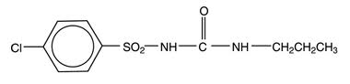  1-(P-chlorobenzene sulphonyl), 3-propyl urea  PHENFORMIN  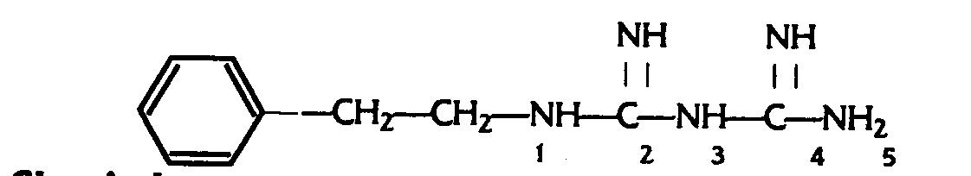  1-(2-phenyl ethyl) biguanide

Insulin: insulin is a hormone produced by beta cells of islets of langrehans. It is a polypeptide containing 51 amino acids arranged in 2 chains namely A & B having 21 & 31 amino acids connected each other by two disulphide bridge. Insulin commonly obtained from pancreas of pig or ox.
Properties: It is a white powder. It is slightly soluble in water, but soluble in dilute solutions of mineral acids. It is inactivated by proteolytic enzymes.
Stability & storage: Insulin is sensitive to heat & light and hence it is stored in well closed containers at a temperature below 8ºC .
Formulation: Insulin injection, Globin zinc insulin Injection, protamin zinc insulin injection, Isophane insulin injection .
Uses: To treat insulin dependent diabetes mellitus (IDDM), to treat diabetic coma.

Oral Hypoglycemic agents: Hypoglycemic agents are the drugs which lower the blood glucose level on oral administration. Ex: chlorpropamide, glipizide, Phenformin.
Classification of oral hypoglycemic agents:-
Oral hypoglycemic agents

- Sulfonyl ureas
- First generation: - Ex: chlorpropamide.
- Second generation :- Ex: Glibinclamide, Glipizide
- Biguanides:- Ex: Metformin, Phenformin

Properties | Chlorpropamide | Phenformin
Physical properties | White crystalline powdered, odourless and tasteless. It is freely soluble in alcohol. | White crystalline powdered, odourless and bitter taste. It is freely soluble in water and alcohol.
Stability and storage | It is stored in well closed containers. | It is stored in well closed containers.
Formulations | Chlorpropamide tablet | Phenformin tablet
Brand name | Diabetol, Diabetin. | Sucranase, Bislim.
Uses | Used to treat:  - Non Insulin dependent diabetes mellitus (NIDDM).  - Mild to moderate diabetes insipidus. | Used to treat non Insulin dependent diabetes mellitus (NIDDM).

Chapter - 23
Diuretics
Diuretics are the drugs which increase the rate of urine output.
They are useful to treat:
- Different types of edema like cardiac edema, edema of pregnancy, renal edema.
- Hypertension along with antihypertensive drugs.
- To reduce intraocular pressure.
Classification :  - Cyclic polynitrogen compound  - Xanthine derivatives:- Ex: Aminophylline, Theophylline  - Pteridine derivatives: - Ex: Triameterine  - Pyrazine derivatives: - Ex: Amiloride  - Sulphonamides  - 1,3,4, thiadiazole derivatives  Ex: Acetazolamide  - Sulphamyl benzoic acid derivatives  Ex: frusemide  - Thiazide derivatives  Ex: chlorthiazide , hydrochlorthiazide ,  benzthiazide.  - Endocrine antagonist  Ex: spironalactone.  - Phenoxyacetic acid derivatives  Ex: ethacrynic acid  - Miscellaneous  Ex: ammonium chloride, mannitol, urea.  UREA  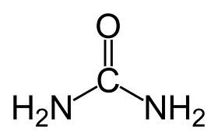  Diamide carbonic acid | FRUSEMIDE  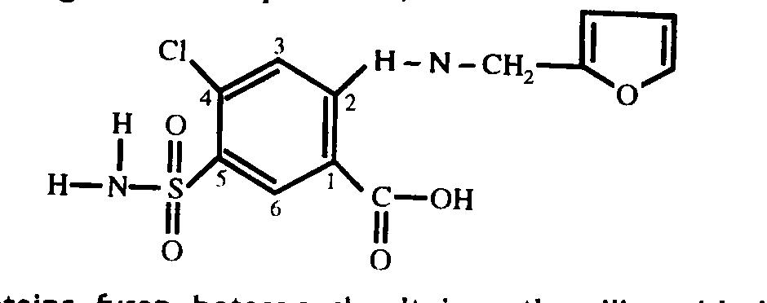  4-chloro,2-furfurylamino,5-sulphamoyl benzoic acid  HYDROCHLORTHIAZIDE  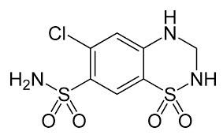 6-chloro,3,4,-dihydro,7-sulphamoyl,2H-1,2,4 benzothiadiazine-1,1-dioxide  MANNINTOL  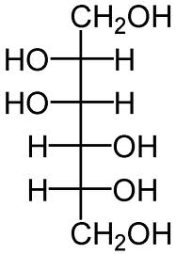  1,2,3,4,5,6-hexahydroxy hexane

Properties | Frusemide | Hydrochlorthiazide | Mannitol | Urea
Physical properties | White crystalline powder, odourless, bitter taste, soluble in water. | White crystalline powder, odourless, bitter taste, soluble in water. | White crystalline powder odourless, sweetish taste, soluble in water. | Colorless crystal, odorless saline taste, soluble in water.
Stabilty & storage | Affected by light. Hence stored in a well closed light resistance container. | Stable compound. Hence stored in well closed container. | Stable compound. Hence stored in well closed container. | It is slightly hygroscopic, affected by heat. Hence it is stored in tightly closed container in a cool place.
Formulation | Frusemide tablet , frusemide injection | Hydrochlorthiazide tablet | Mannitol injection | Urea injection, urea cream.
Brand name | Lasix , salurex | Biduret, Esidrex | Osmitrol | Cotaryl- H, Trazine.
Use | It is used  - As a diuretic t  - for the management of hypertension | It is used  - As a diuretic  - for the management of hypertension | It is used  - As a diuretic  - As a diagonist agent  - For irrigation of bladder  - As a diluents and excipients | It is used  - As a diuretic  - To treat dry skin condition.  - To treat eczema.  - To treat skin ulceration.  - To get relief from vomiting and headache.

Chapter - 24
Histamine and Antihistamine
Histamine is biological amines. It is formed by decarboxylation of histidine. It is mainly formed in biological fluids, platelets, leucocytes, basophils, mast cell of lungs, GI mucosa. Histamine after release act on two types of histamine receptor (H₁ and H₂) in our body. As such histamine has no diagnostic and therapeutic uses, it has only experimental uses.
Antihistamines are the drug which blocks the action of histamine, which liberate in the body. Antihistamine mainly blocks the action of histamine on H₁ receptor.
Classification of Antihistamine  1 Amino alkyl ether  Ex: Diphenhydramine  2 Ethylene diamine  Ex: Mepyramine, Antazoline  3 Alkyl amines  Ex: Pheniramine, Chlorphenerimine  4 Phenothiazine derivatives  Ex: Promethazine  5 Piperazine derivatives  Ex: Meclazine, Buclizine  6 Miscellaneous  Ex: Cyproheptadine | DIPHENHYDRAMINE  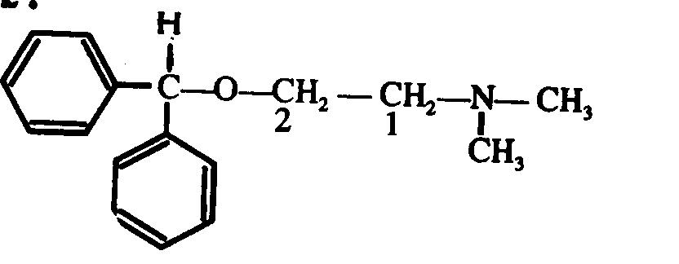  1-dimethylamino,2-diphenylmethoxy ethane  CHLORPHENIRAMINE  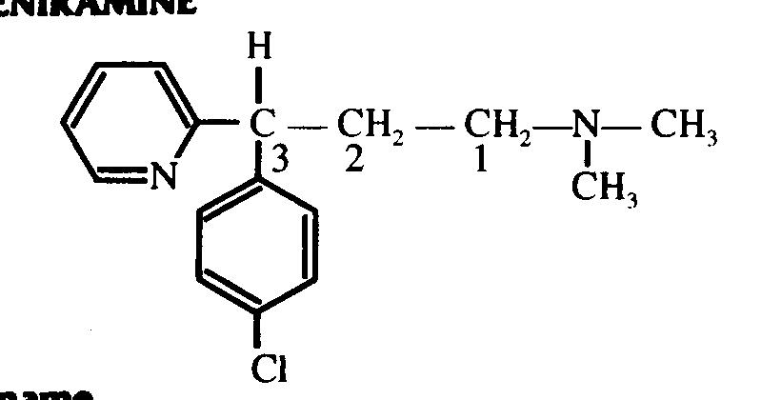  3-(P-chlorophenyl),3-(pyrid-2-yl),N,N-dimethyl propamine

Properties | Diphenhydramine | Chlorpheniramine
Physical properties | White crystalline powder, odorless, bitter taste, soluble in water. | White crystalline powder, odorless, bitter taste, soluble in water.
Stability & storage | It darkens slowly on exposure to light and hence stored in tightly closed light resistance container. | It darkens slowly on exposure to light and hence stored in tightly closed light resistance container.
Formulation | Diphenhydramine capsule , Diphenhydramine Elixir | Chlorpheniramine Injection  Chlorpheniramine Elixir
Brand name | Benadryl, Caladryl | Corex, Alergin
Use | Used to treat:  - Allergic skin reaction  - Motion sickness and post operative vomiting.  - Cardiac arrhythmia in combination with antazoline | Used to treat:  - Allergic skin reaction  - Motion sickness and post operative vomiting.  - Cardiac arrhythmia in combination with antazoline

Chapter - 25
Diagnostic Agents
Diagnostic agents are the chemicals or substances that are used to detect abnormalities in tissues or organ or to test on organs. These agents do not usually have any medical values or pharmacological effects; they are useful for the clinical diagnosis of diseases. The diagnostic agent can be discussed under following heads:

- Radiopaques (X-ray contrast media)
Ex: Iopanic acid, Propyliodone

- Agents used to treat organ functions:
- To test kidney function
Ex: Indigotindisulphonate (Indigo caramine)
- To test liver function
Ex: Sulphobromophthalein sodium
- Miscellaneous
Ex: Fluorescein sodium, Evans blue, Congo red

Iopanic acid  Properties: White or cream coloured powder, odour less, tasteless.  Stability and storage: Affected by light. Hence stored in well closed light resistant containers  Formulations: Iopanic acid tablet  Uses: It is used as a contrast medium in radiography of gall bladder. | Indigo caramine  Properties: Purpulish blue powder or blue granules. It is sparingly soluble in water.  Stability and storage: Affected by light. Hence stored in well closed light resistant containers  Formulations: Indigo caramine injection  Uses: to test kidney functions | Evans Blue  Properties: green or bluish green powder, odour less, soluble in water.  Stability and storage: In dry form it is hygroscopic. Hence stored in a tightly closed containers.  Formulations: Evans blue injection  Uses: It is used as a diagnostic agent to determine blood volume.

Chapter - 26
Steroidal Drugs
A steroid is a type of organic compound that contains characteristic arrangements of four cyclo alkane rings, that are joint to each other. The three cyclohexane rings (designated as ring A, B, C) and one cyclopentane ring (designated as D). The methyl group present at position number 13 and 10 is numbered as 18 and 14 respectively. 100 of different steroid are found in the plants, animals and fungi such as
- Dietary fat: cholesterol
- Sex hormones: estradiol, testosterone
- Anti-inflammatory: dexamethasone
CHEMICAL CLASSIFICATION OF STEROID | BASIC STRUCTURE OF STEROIDAL DRUG  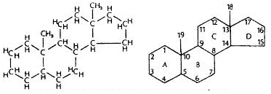
  Class | Examples | Number of carbon atoms
  Cholestanes | cholesterol | 27
  Cholanes | cholic acid | 24
  Pregnanes | progesterone | 21
  Androstanes | testosterone | 19
  Estranes | estradiol | 18

Chapter - 27
Adrenergic Drugs
The drugs that produce pharmacological effects like adrenaline or nor-adrenaline or drugs which bring stimulation of adrenergic nerve are called adrenergic drugs or sympathomimetics or adrenomimetics or adrenergic stimulants.
Classification  1 Catacholamines  Ex: adrenaline, nor-adrenaline, isoprenaline  2 Non-catacholamines  - Containing phenyl ethylamine skeleton  - With phenolic group  Ex: salbutamol, phenylphrine  - Without phenolic hydroxy group  Ex: ephedrine  - Aliphatic amines  Ex: cyclopentamine  - Imidazoline derivatives  Ex: naphazoline | ADRENALINE EPHEDRINE  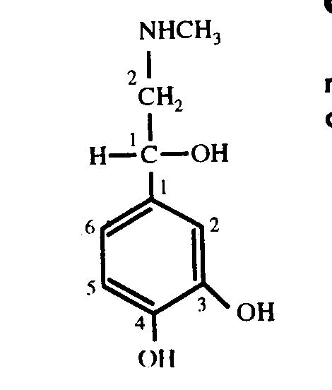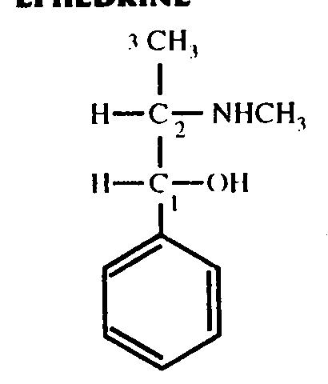  (R) -1-(3,4-dihydroxyphenyl), D-(-)-erythro-2-methyl amino  2-methylamino ethanol 1-phenyl propan-1-ol  ISOPRENALINE  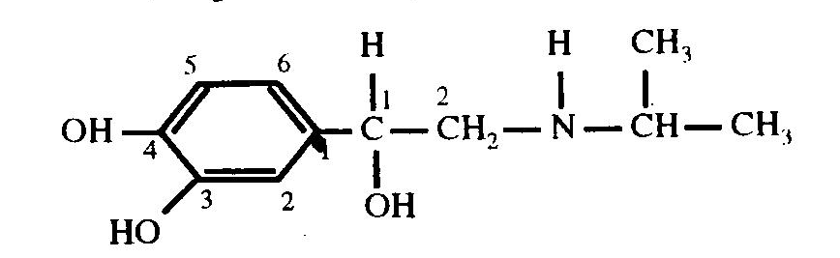  1-(3,4-dihydroxyphenyl),2-isopropyl amino ethanol

Properties |  | Adrenaline | Isoprenaline |  | Ephedrine
Physical properties |  | Creamy white microcrystalline powder, odourless, bitter taste, soluble in mineral acids and of alkali hydroxides. | White crystalline powder, odourless, bitter taste, soluble in water. |  | White crystalline powder, odourless, bitter taste, soluble in water.
Stability & Storage |  | It contains catechol nucleus which can be oxidized readily with air or oxygen to get pink or red coloured complex. It darkens on exposure to light and air. Hence it is stored in tightly-closed light-resistant containers. | It gradually darkens on exposure to air and light. Presence of metal also causes discolouration. Hence it is stored in tightly-closed light-resistant container. |  | It gradually decomposes on exposure to light. Hence it is stored in tightly-closed light-resistant container.
Formulations |  | Adrenaline injection, Adrenaline eye drops, Adrenaline solutions | Isoprenaline hcl injection  Isoprenaline aerosol inhalation,  Slow release isoprenaline tablets  . |  | Ephedrine tablet,  Ephedrine nasal drops  Ephedrine elixir  .
Brand name | Medicreme, Inhalant |  | Autohaler, Neo-epinine
Uses | It is used:  1 To relieve bronchial spasm  2 To treat heart block  3 To treat acute allergic reaction( rhinitis, hay fever)  4 To control superficial haemorrhage of nose and throat  5 With local anaesthetics, to prolong local anaesthetic effect. |  | 1 It is mainly used to treat bronchospasm in bronchial asthma  2 In emergency, it is used to treat cardiotoxic shock states, heart block or severe bradycardia | It is used to treat:  1 asthma  2 nocturnal enuresis in children  3 nasal con

Chapter - 28
Adrenolytics Drugs
The drugs that decrease the sympathetic activity are called as adrenolytics or sympatholytics or adrenergic antagonists or adrenergic blocking agents.
CLASSIFICATION  1 α- adrenergic blockers  Ex: Tolazoline  2 β- adrenergic blockers  Ex: Propranolol, practolol | PROPRANOLOL  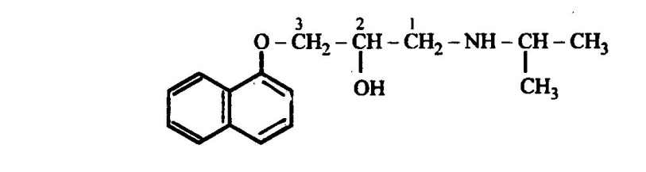  1-isopropylamino,3-(1-napthyloxy) propan-2-ol

Properties | PROPRANOLOL
Physical Properties | White powder, odourless, bitter taste, soluble in water.
Stability and Storage | Affected by light. Hence stored in air- tight light- resistant containers.
Formulation | Propranolol Tablet, Propranolol injections
Brand name | Arminol, Norten, Prolol, Ciplar
Uses | It is used:  - To treat hypertension  - In emergency, to treat cardiac arrhythmia.
Chapter - 29
Cholinergic Drugs
The drugs which exert pharmacological actions like acetylcholine or drugs which bring about stimulation of cholinergic nerves are called cholinergic drugs or cholinergic agonist or cholinomimetic drugs. As these drugs bring about stimulation of parasympathetic nervous system, they are also called as parasympathomimetic drugs.
CLASSIFICATION  1 Cholinergic agonist (direct acting)  - Ester of choline  Ex: acetylcholine  - Alkaloids  Ex: pilocarpine  2 Indirect acting cholinergic agonist  Ex: Neostigmine, physostigmine | NEOSTIGMINE  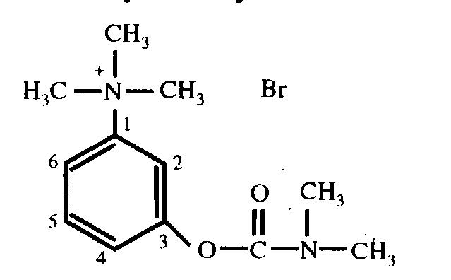  PHYSOSTIGMINE  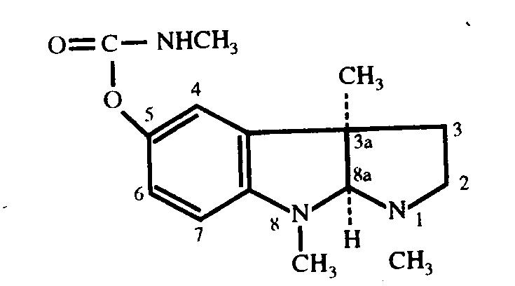

Properties | Neostigmine | Physostigmine
Physical properties | Colourless crystals, odourless, bitter taste and soluble in water. | Colourless crystals, odourless, soluble in water.
Stability & storage | It is affected by light and air. Hence stored in tightly closed light resistance container. | It becomes pink on exposure to light and air. Hence stored in tightly closed light resistance container.
Formulation | Neostigmine tablet  Neostigmine injection | Physostigmine Injection  Physostigmine eye drops
Brand name | Prostigmine | Eserine with pilocarpine
Use | It is used:  - To treat myasthenia gravis  - To treat paralytic ileus.  - For post operative urinary retention  - As muscle relaxants | Used to treat:  - Glaucoma  - Psychiatric and neurologic disorders  - Poisoning with anticholinergic drugs

Chapter - 30
Anti-Cholinergic Drugs
The drugs which inhibit pharmacological actions of acetylcholine are known as anticholinergic or parasympatholytics or cholinolytics. The anticholinergic drugs which inhibit muscranic actions of acetylcholine are called as antimuscranic drugs.
CLASSIFICATION  1 Amino alcohol esters  Ex: Atropine, Hyoscine, Propantheline  2 Amino alcohol ethers  Ex: Benzotropine  3 Amino alcohols  Ex: Biperiden  4 Amino amides  Ex: Tropicamide  5 Miscellaneous  Ex: Pirenzipine, Ethopropazine | ATROPINE  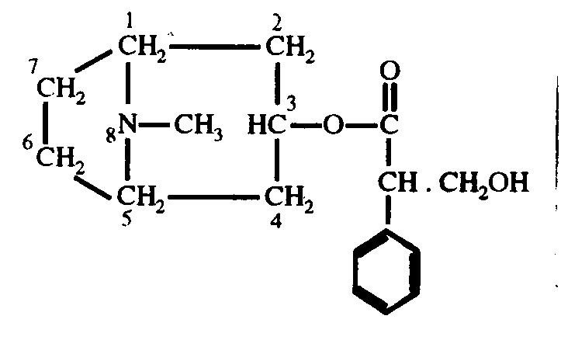 BIPERIDEN  PROPANTHELINE 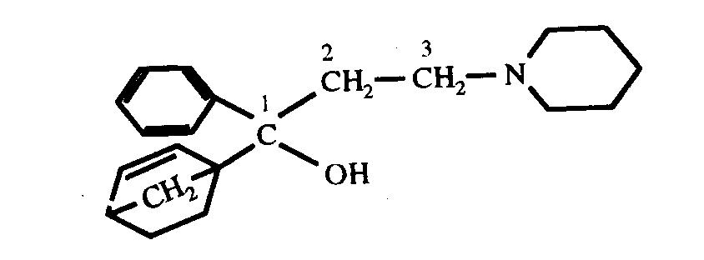  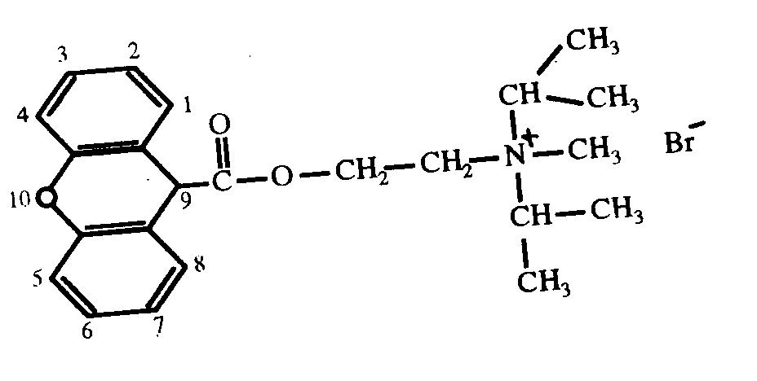

Properties |  | Atropine | Propantheline |  | Biperiden
Physical properties |  | White crystalline powder, odourless, bitter taste, soluble in chloroform.. | White powder, odourless, bitter taste, soluble in water. |  | White crystalline powder, odourless, bitter taste, soluble in chloroform.
Stability & Storage |  | It is affected by light. Hence it is stored in tightly-closed light-resistant containers. | It is hygroscopic. Hence it is stored in tightly-closed container. |  | It is affected by light. Hence it is stored in tightly-closed light-resistant containers.
Formulations |  | Atropine injection,  Atropine eye drops,  Atropine sulphate tablet, Atropine eye ointment. | Propantheline injection  Propantheline tablet |  | Biperiden hcl tablet  Biperiden lactate injection
Brand name | Eumydrin |  | Profanthine | Akineton
Uses | It is used:  1 To treat parkinsonism  2 CNS stimulant in small dose  3 As a mydriatic  4 As an antispasmodic  5 As apre-anaesthetic medication  6 to treat organ phosphorous poisoning. |  | It is used:  1 To treat gastric and duodenal ulcers  2 To treat intestinal hyper motility  3 To reduce gastric secretions.  4 To control excessive sweating and salivation  5 To prevent nocturnal enuresis in children  6 To reduce biliary and ureteric spasm. | It is used:  1 To treat all types of parkinsonism diseases

